**IMPACT OF COVID 19 ON THE USA AIR POLLUTION AND FOOD INSECURITY**

1Dinesh Vennapoosa, 2Kavya Gustala.  3Varshini Singamaneni, 4Mohammed Asmatahasin, 5Surat Srinivasa Ayyappa Prasad, 6Oludare Odewenwa, 7Tanneru Naga Shalini

**1Indiana University-Purdue University, Indianapolis, IN 46202, USA**

divenna@iu.edu, kgustala@iu.edu, vsingam@iu.edu, mohamas@iu.edu, srisurat@iu.edu, oodewenw@iu.edu, ntanneru@iu.edu

**ABSTRACT:** COVID-19 is an acknowledged global pandemic. Beginning in 2019 and dramatically escalating from 2020 to the future in proportions that have not been witnessed in previous years, it had a profound influence on society and daily life. Significant impacts on food and air have resulted in increased rates of food poverty and better air quality. Two hypotheses are to be tested in the study utilizing machine learning for prediction and statistical testing for relationship among variables. In both hypotheses, we were able to demonstrate statistical significance, revealing that the factors we looked at had a substantial influence on both AQI and food insecurity. Insights from this study can be used in future studies to foresee situations comparable to the one at hand.

**KEYWORDS:** COVID-19, Air quality index, Food insecurity, ARIMA, Mann and Whitney U test, Kruskal Wallies test, SMOTE analysis, Silhouette method

**1. SCOPE OF THE PROJECT**

* **1.1 Introduction**
* **1.2 Aim**
* **1.3 Purpose**

**2. METHODOLOGY**

* **2.1 Phases of the Project**
* **2.2 Members of the team and their responsibilities**

**3. DATA COLLECTION**

**4. DATA EXTRACTION AND STORAGE**

* **4.1. Data Extraction**
* **4.2. Data Import**
* Fig 1 – Imported air pollutants CSV files
* Fig 2 - Imported meteorological features CSV files
* Fig 3 – Imported trips by distance CSV file
* **4.3. Data Cleaning**
* Fig 4 - Dataset after merging of COVID-19 and air pollution dataset – 1
* Fig 5 - Detecting null values for dataset - 1
* Fig 6 - Detecting duplicates for dataset - 1
* Fig 7 - Using pandas describe () to identify outliers
* Fig 8 - Detection of outliers using IQR method
* Fig 9 - Outliers detection using Box Plot for dataset – 1
* Fig 10 - Handling outliers using flooring and capping method
* Fig 11 - Percentage of outliers after handling of dataset – 1
* Fig 12 - Data cleaning of dataset – 1
* Fig 13 - Dataset after merging of COVID-19 and food insecurity
* Fig 14 - Percentage of null values before dropping
* Fig 15 - Dropping null instances of dataset – 2
* Fig 16 - Handling of duplicates for dataset – 2
* Fig 17 - Outlier detection for New covid cases
* Fig 18 - Data cleaning of dataset – 2

**5. DATA ANALYSIS**

* **5.1. Descriptive Statistics**
* **5.1.1. Statistical Data Distributions**
* Fig 19 – Pair plot using seaborn
* Fig 20 - Histograms for univariate continuous variables
* Fig 21 – Histogram plot showing frequency of good and moderate air quality
* Fig 22 – Box plots for continuous variables
* Fig 23 – Bar plots
* Fig 24 – The trend of continuous variables using line plots with its mean and maximum values
* Fig 25 - The trend of continuous variables using scatter plots with its mean and maximum values
* Fig 26 – Regression plots of AQI vs other continuous independent variables
* Fig 27 - Grouped bar charts states vs AQI
* Fig 28 - Bar plots of categorical variables with mean value of dependent variable for Texas
* Fig 29 - Line plot of continuous dependent variables by independent categorical variables over a period
* **5.1.2. Normality Test and Shapiro test**
* Fig 30 – Normality test for dataset – 1
* Fig 31 – Skew test for dataset – 1
* Fig 32 - Shapiro test for dataset – 1
* Fig 33 - Normality test for dataset - 2
* Fig 34 – Skew test for Continuous values in a dataset - 2
* Fig 35 - Shapiro test for data set - 2
* **5.1.3. Visualization**
* **5.1.4. Correlation**
* Fig 36 - Correlation heat map of dataset -1
* Fig 37 - Correlation heat map of dataset -2
* **5.2. Hypothesis Testing**
* **5.2.1. Mann and Whitney U test**
* Fig 38 – Mann Whitney U test for testing Null hypothesis
* Fig 39 - Post HOC method for covid cases vs AQI
* Fig 40 - Hypothesis testing for population Not staying at home
* Fig 41 - Hypothesis testing for Number of Trips
* Fig 42 – Levene’s test for 'often not enough to eat’ for age group
* **5.2.2. Kruskal Wallis test**
* Fig 42 – Levene’s test for 'often not enough to eat’ for age group
* **5.2.3. Levene test**
* Fig 43 – Kruskal Wallis test for age group
* **5.3. Supervised Learning**
* **5.3.1. Model Development**
* **5.3.2. Performance Analysis** 
  + - * **5.3.3.1. Multiple Linear Regression**
      * **5.3.3.2. Support Vector Regression**
      * **5.3.3.3. Decision Tree**
      * **5.3.3.4. Random Forest**
        + Fig 44 – Random Forest results for data set –1
        + Fig 45 – Random Forest using K fold validation and grid search for data set –1
        + Fig 46 – Applying SMOTE analysis or dataset - 1
        + Fig 47 - Random Forest results for data set –1 after SMOTE
        + Fig 48 - Random Forest using K fold validation and grid search results for data set –1 after SMOTE
        + Fig 49 – Silhouette analysis for dataset – 1
        + Fig 50 – K means clustering for dataset – 1 before SMOTE
        + Fig 51 – K means clustering for dataset – 1 after SMOTE
        + Fig 52 – Hierarchical agglomerative clustering representation using a dendrogram
        + Fig 53 – Hierarchical clustering for Unbalanced data set – 1
        + Fig 54 – Hierarchical clustering for balanced data set – 1
        + Fig 55 – Histogram for K-means cluster 0 for unbalanced dataset – 1
        + Fig 56 - Histogram for K-means cluster 1 for unbalanced dataset – 1
        + Fig 57 – Histogram for K-means cluster 0 for balanced dataset – 1
        + Fig 58 – Histogram for K-means cluster 1 for balanced dataset – 1
        + Fig 59 – Histogram for Hierarchical cluster 0 for unbalanced dataset – 1
        + Fig 60 – Histogram for Hierarchical cluster 1 for unbalanced dataset – 1
        + Fig 61 – Histogram for Hierarchical cluster 0 for balanced dataset – 1
        + Fig 62 – Histogram for Hierarchical cluster 1 for balanced dataset – 1
        + Fig 63 - Forecasting the Often not enough to eat for the USA for people whose age between '55-64'-64'
        + Fig 64 - Interpreting residual plots
        + Fig 65 - Normal Q-Q plot
        + Fig 66 - Correlation USA Often not enough to eat for age 55-64
        + Fig 67 - Forecast for COVID cases for the US

**6. SUMMARY**

**7. LIMITATIONS**

**8. CHALLENGES**

**1**  **SCOPE OF THE PROJECT**

**1.1**  **Introduction**

The Coronavirus disease 2019 (COVID-19) which first appeared in Wuhan China in December 2019 is an ongoing global pandemic. COVID-19 is a contagion that has made a significant impact on people's lives and activities since 2019 with a great impact from 2020 to the present in ways that have not been seen in recent times. As part of the measure to prevent the spread of COVID-19, the World Health Organization (WHO) advises social distancing as one of the main strategies to fight against the Virus. As a result, several nations enforced social distancing through mobility restrictions and confinement measures. Consequently, it affected people’s health, economy, transportation, education, employment, and environment. In this study, we are going to study the short-run (February to April 17, 2020 – a period when most countries followed strict lockdowns) and long-run impact of covid restrictions on Air quality by examining changes in the concentration of air pollutants such as PM2.5, CO, SO2, PM10, NO2, O3 and by measuring overall Air Quality Index (AQI).

The information needed to study urban air pollution is combined from various sources in this time series, including the pollutants themselves, city traffic, pollution from power generation industries, and meteorological factors. Over two years, daily data was collected for more than 50 US cities. nearly, the AQI is measured (AQI Category, Score Range, Color Code) as (Good, 0-50, Green), (Moderate, 51-100, Yellow), (Unhealthy for Sensitive Group, 101-150, Orange), (Unhealthy, 151-200, Red), (Very Unhealthy, 201-300, Purple), (Hazardous, 301-500, Maroon). Environmentalists and researchers are calling this pandemic a “blessing in disguise”- as lockdowns have drastically reduced air pollution (Muhammad et al., 2020).” According to NASA and the ESA, air pollution in some of the epicenters of COVID-19 such as Wuhan, Italy, Spain, and the USA, etc. declines by up to 30% (Muhammad et al., 2020).”

One of the studies by the Department of International Business, University of Dhaka, Dhaka 1000 on “The impact of COVID-19 on air pollution: Evidence from global data” states that “Carbon Monoxide emissions in US-Canada respond to indoor and outdoor mobility changes in both the short (1.1%) and long run (−1.4%)”. We perform a regression analysis to predict the AQI and cluster analysis to cluster the regions of the US that have similar AQI based on several covid cases and to interpret the relationship between the increase in the covid cases and the quality of air increased or decreased.

Furthermore, we will also research how covid 19 affected people’s food insecurity across different demographics of the USA. Low-income communities and communities of color are predominantly affected by food insecurity, especially those with limited or inconsistent accessibility to adequate, nourishing sustenance for a productive, healthier lifestyle. It is evident that due to the pandemic food insecurity has increased. “At the national level, we project 54 million food-insecure Americans in 2020, approximately 17 million higher than in 2018.” For children, the food insecurity rates are projected to increase to 18 million, up nearly 7 million from 2018. (Craige Gundersen et al,2021).

Overall, 36% of low-income adults in the US were food secure, 20% had marginal food security, and 44% were food insecure (Wolfson, J. A., & Leung, C. W. et al.,2020). Our project collects data from the “United States Census Bureau's Pulse Survey”. The Pulse Survey is a frequently updated survey designed to collect data on how people's lives have been impacted by the coronavirus. On this dataset, we are going to perform Exploratory Data Analysis (EDA) to extract insights to understand the impact of covid 19 on food access of different kinds of people by their Income, sex, race etc.

To determine the extent of the impact of COVID-19 on the environment and food insecurity, three separate datasets were combined, including the number of persons affected by COVID-19, the US-Environment air pollution dataset, and the Covid-19 Food Insecurity Dataset.

**1.2**  **Aim**

The project aims to accomplish two things.

a) Assessing COVID-19's impact on air pollution in the USA is the primary goal.

b) Identifying the impact of COVID-19 on food insecurity in the USA and providing analysis to predict a situation such as this in the future are the secondary goals.

**1.3**  **Purpose**

The study's focus was on identifying the impacts of COVID-19 on food, the extent of food insecurity, the dimensions of food security that were most severely affected, and the variables associated with those characteristics. In addition to determining how pervasive food insecurity was, the study's objectives are to raise public awareness of how air pollution has been decreased as a result of people reduced outdoor mobility for longer periods of time during the epidemic. The degree of food insecurity prior to will be assessed and following the emergence of COID-19 will be compared, and the results will be interpreted using time series analysis to forecast a similar situation in the future.

**HYPOTHESIS FOR AIR POLLUTION**

Null hypothesis: An uptick in COVID-19 cases has no discernible impact on a reduction in polluted air in the USA and cannot predict the Air Quality Index (AQI).

Alternative hypothesis: An uptick in COVID-19 cases has a discernible impact on a reduction in polluted air in the USA and can predict the Air Quality Index (AQI).

**HYPOTHESIS FOR FOOD INSECURITY**

Null hypothesis: The variables we looked at from the "Covid-19 Food Insecurity" dataset demonstrate that Covid-19 had no effect on the food shortages in the US for various demographic groups in the USA.

Alternative hypothesis: The variables we looked at from the "Covid-19 Food Insecurity" dataset demonstrate that Covid-19 had significant effect on the food shortages in the US for various demographic groups in the USA.

**2** **METHODOLOGY**

**2.1** **Phases of the Project**

The study was a quantitative research study. We used Python Jupyter Notebook for coding. We shall go into more depth about our project methodology's key dimensions in the following paragraphs.

1. Data Collection

2. Data Extraction and Storage

3. Data Analysis

4. Data Visualization

**2.2** **Members of the team and their responsibilities**

|  |  |  |
| --- | --- | --- |
| **TEAM MEMBER** | **BACKGROUND** | **RESPONSIBILITIES** |
| Tanneru Naga Shalini | Bachelor of Technology in Biotechnology, New to Python | Data extraction  Data preprocessing |
| Dinesh Vennapoosa | Bachelor of Technology in Mechanical Engineering, have knowledge of Python, machine learning models. | Regression model development  Clustering analysis and Evaluation  Exploratory Data Analysis  Data visualization of clustering |
| Surat Srinivasa Ayyappa Prasad | Bachelor of Dental Surgery, New to Python | Exploratory Data Analysis on both datasets. |
| Varshini Singamaneni | Bachelor of Dental Surgery, New to Python | Building and evaluating of Multiple linear regression model and Support Vector Machine (SVM) using Python |
| Mohammed Asmatahasin | Bachelor of Dental Surgery, New to Python | Building and evaluating of Random Forest and Decision Tree using Python  Visualization of Random Forest and Decision Tree using Python |
| Oludare Odewenwa | Bachelor of Education, Associate in Informatics. 1 year experience in Object Oriented Programming (Java), MySQL, | Building and evaluation of K-means and Hierarchical clustering  Data visualization of clusters |
| Kavya Gustala | Bachelor of Technology in Biotechnology, New to python | Project proposal  Model’s performance analysis  Presentation  Final project report |

**3** **DATA COLLECTION**

As the phrase suggests, a collection is a group of things, and data is a subset of information. When used together, the term "data types" refers to a collection of information that contains a variety of unique objects. In order to handle research challenges, respond to questions, considered the final, and anticipate future trends and possibilities, data collecting is the process of acquiring, measuring, and analyzing accurate data from a limited number of relevant sources. Our data have been collected from different websites as we worked on three different datasets where we merged the Covid dataset with the rest of the two Air pollution datasets and the Food Insecurities dataset such that in total, worked on two datasets. We have collected three years of data from 2020,2021,2022 in each dataset.

1. US State COVID-19 dataset:

“(<https://github.com/nytimes/covid-19-data/tree/master/live>) “

us-states-covid.csv

2. Covid-19 Food Insecurity Data:

“(<https://www.kaggle.com/datasets/jackogozaly/pulse-survey-food-insecurity-data?resource=download>)”

Final_Pulse_Data.csv

3. US-Environment air pollution:

United States Environmental Protection Agency:

(<https://aqs.epa.gov/aqsweb/airdata/download_files.html>)

daily_co_2020.csv, daily_co_2021.csv, daily_co_2022.csv, daily_no2_2020.csv, daily_no2_2021.csv, daily_no2_2022.csv, daily_ozone_2020.csv, daily_ozone_2021.csv, daily_ozone_2022.csv, daily_pm10_2020.csv, daily_pm10_2021.csv, daily_pm10_2022.csv, daily_pm2.5_2020.csv, daily_pm2.5_2021.csv, daily_pm2.5_2022.csv, daily_so2_2020.csv, daily_so2_2021.csv, daily_so2_2022.csv, daily_aqi_by_county_2020.csv, daily_aqi_by_county_202.csv daily_aqi_by_county_2022.csv, daily_PRESS_2020.csv, daily_PRESS_2021.csv, daily_PRESS_2022.csv, daily_RH_DP_2020.csv, daily_RH_DP_2021.csv, daily_RH_DP_2022.csv, daily_TEMP_2020.csv, daily_TEMP_2021.csv, daily_TEMP_2022.csv, daily_WIND_2020.csv, daily_WIND_2021.csv, daily_WIND_2022.csv

4. Trips by Distance:

U.S. Department of Transportation:

(<https://data.bts.gov/Research-and-Statistics/Trips-by-Distance/w96p-f2qv>)

Trips_by_Distance.csv

**4** **DATA EXTRACTION AND STORAGE**

**4.1**  **Data Extraction**

Acquiring useful information from several sources is known as data extraction. The sources from which we have collected the data are in CSV format. Our data came from webpages and CSV files, among other places.We conducted a review of all the variables and the descriptions of those variables utilizing the data dictionary excel spreadsheet. We limited the variables to those that were most appropriate for our study's objectives. We selected the characteristics we thought would most likely demonstrate a substantial influence of COVID-19 on air pollution and food insecurity in the USA. The description of the two datasets and their variables is given below.

In Air Pollution 18 attributes we selected are below:

1. Date
2. State Name
3. New Covid Cases
4. Population Staying at Home
5. Population Not Staying at Home
6. Number of Trips
7. pm10_mean
8. pm25_mean
9. co_mean
10. no2_mean
11. o3_mean
12. so2_mean
13. press_mean
14. rh_mean
15. temp_mean
16. wind_mean
17. AQI
18. Category

In Food insecurity 30 attributes we selected are below:

1. Enough of the kinds of food wanted
2. Enough Food, but not always the kinds wanted
3. Sometimes not enough to eat
4. Often not enough to eat
5. Age
6. Sex_At_Birth
7. Race
8. Education
9. Marital_Status
10. children_Present
11. Unemployed_Last_4
12. Employed_Last_7
13. Reason_Not_Working
14. Receiving_Pay_No_Work
15. Income
16. Health_Status
17. Covered_By_Insurance
18. Caught_Up_On_Mortgage
19. Location
20. Household_Size
21. Active_Duty
22. House_Receives_SNAP
23. Used_To_Meet_Needs
24. Provider_Of_Free_Groceries
25. Freq_Feel_Depressed
26. Freq_Feel_Anxious
27. Year
28. week_name
29. Week
30. New Covid Cases

The most significant attributes identified by our data analysis are described below. In order to perform the greatest possible analysis of the data, we wanted to be certain that we fully understood it. We could use the data to draw more accurate conclusions if we were aware of our characteristics. Following are descriptions:

* New Covid Cases – It contains the statewide daily new cases of Covid 19
* AQI – It contains the Statewide Air Quality Index values
* Food not enough to eat – It contains the number of people who answered yes to the question “Food not enough to eat” across different demographic groups and characteristics.

**4.2 Data Import**

We have collected our datasets from different websites and imported the required files that are necessary for our project into Myjupyter.

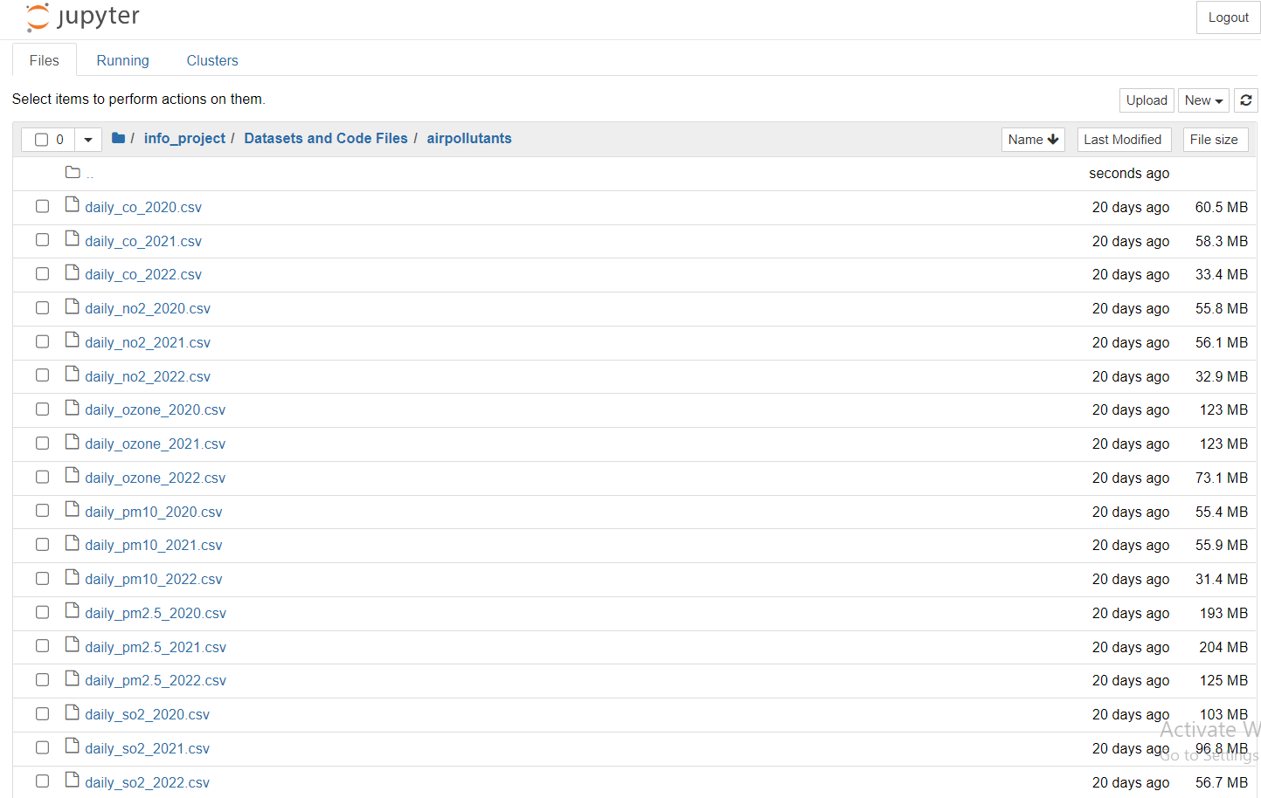

**Fig 1 – Imported air pollutants CSV files** 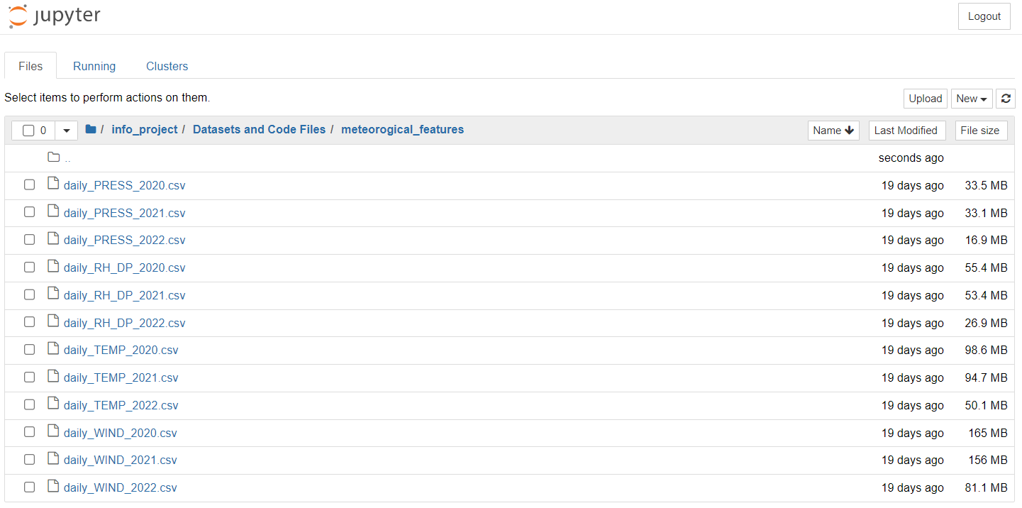

**Fig 2 - Imported meteorological features CSV files** 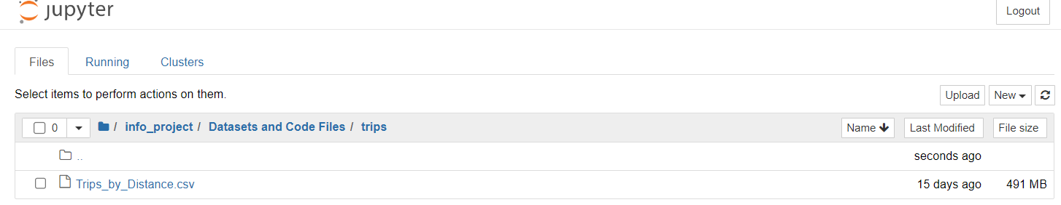

**Fig 3 – Imported trips by distance CSV file**

**4.3** **Data Cleaning**

Finding and changing erroneous, redundant, incomplete, or unnecessary parts of raw data is the process of "data cleaning." We have cleaned our datasets by taking the CSV files of the COVID-19 dataset, air pollution dataset, and food insecurity dataset.

**DATASET – 1**: The dataset presents large-scale data involving all the key contributors to urban air pollution, including the pollutants themselves, city traffic, pollution from power generation industries, and meteorological factors. In our sub-dataset, we have checked for outliers' duplicates and null values. Data items that considerably differ from the rest of the objects are known as outliers. Measurement or execution mistakes may be the root of them. It is considered a duplicate if a number, string, or other list item appears more than once. We have checked for null values. Unknown or uninitialized variables are referred to as null values. Later, we merged all sub-datasets on the common columns 'Date’, ‘State Name' and performed all data cleaning methods such as outliers' detection and handling, duplicated detection and handling, finding and handling missing values, checking for datatypes and fixing structural errors. All the data cleaning methods performed on the final merged dataset “Air pollution” are show below.

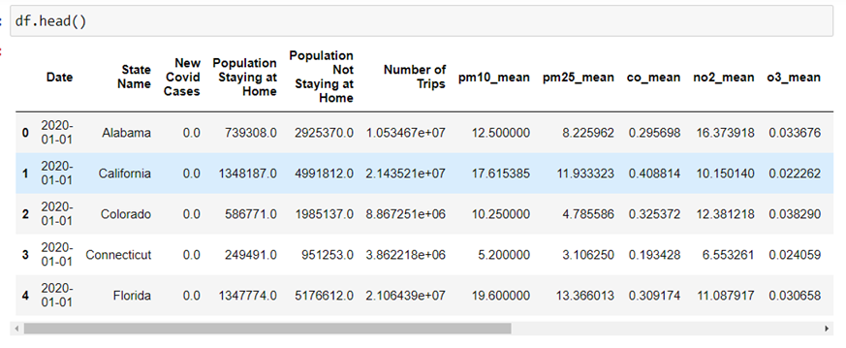 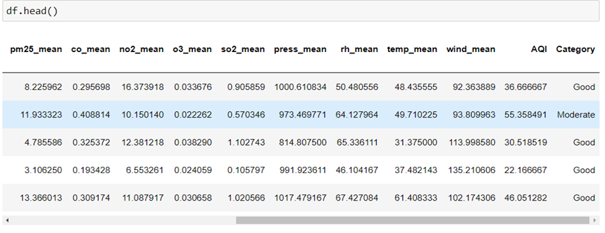 **Fig 4 - Dataset after merging of COVID-19 and air pollution dataset – 1**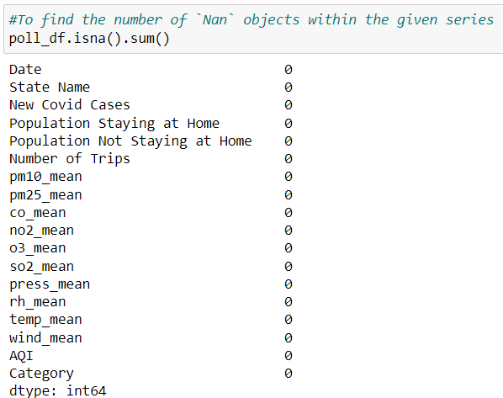

**Fig 5 – Detecting null values for dataset – 1**

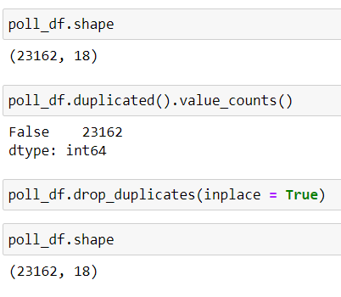

**Fig 6 – Detecting duplicates for dataset – 1**

This merged dataset has zero missing values, and zero duplicate instances were present. We have introduced a new column known as ‘category’ where the quality of air is being distributed as ‘good’ and ‘moderate’ based on the information from the "US Air Quality 1980-Present" dataset. We have used pandas to find outliers and run the boxplot method for detecting outliers.

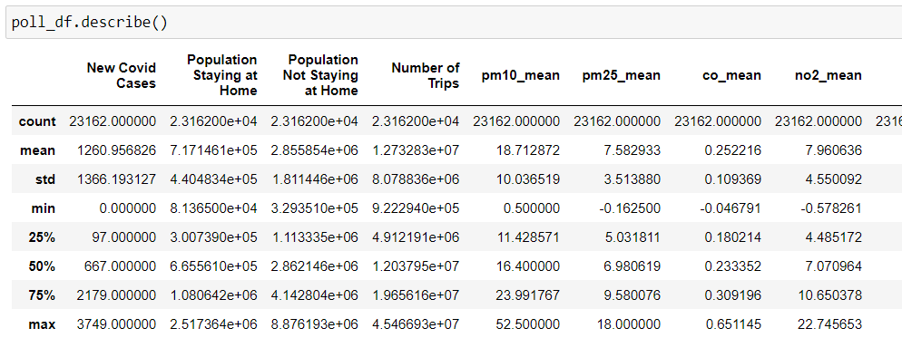

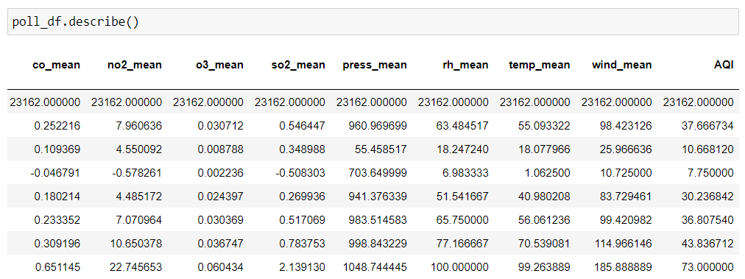**Fig 7 - Using pandas describe () to identify outliers**

**OUTLIER DETECTION USING IQR:**

**IQR:** Inter Quartile Range is used to detect outliers. The spread between the 75th and 25th percentiles of a set of data is known as the interquartile range, or IQR. While it is a measure of dispersion similar to standard deviation, it is much more robust against outliers. When a test is run for outliers, using IQR method it is found that outliers were present, and they are needed to be handled.

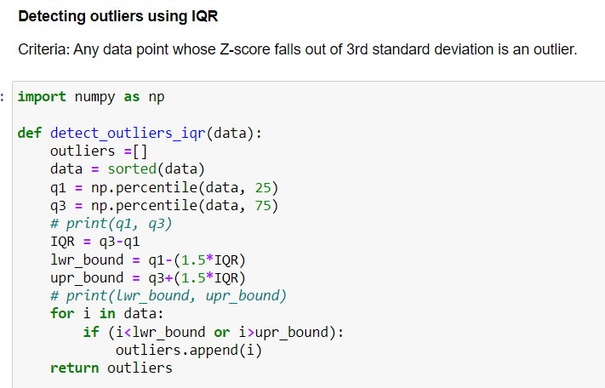 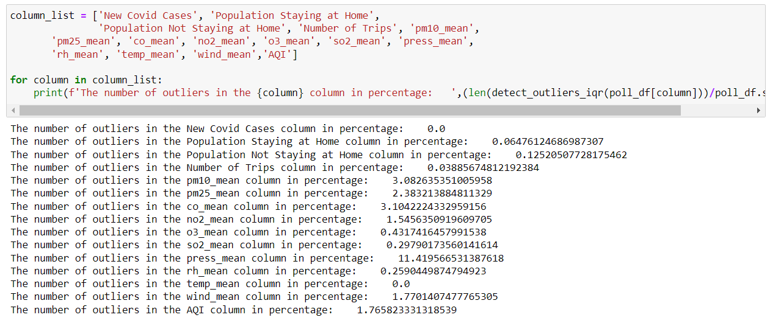**Fig 8- Detection of outliers using IQR method**

**OUTLIER DETECTION USING BOXPLOT**

In our datasets, we have checked for outliers using the box plot method. The overview of a group of data values with features like minimum, first quartile, median, third quartile, and maximal is displayed using a box plot. In the box plot, a box is made between the first and third quartiles, and a vertical line also appears, passing through the box at the median. It is evident from this visualization that outliers were present.

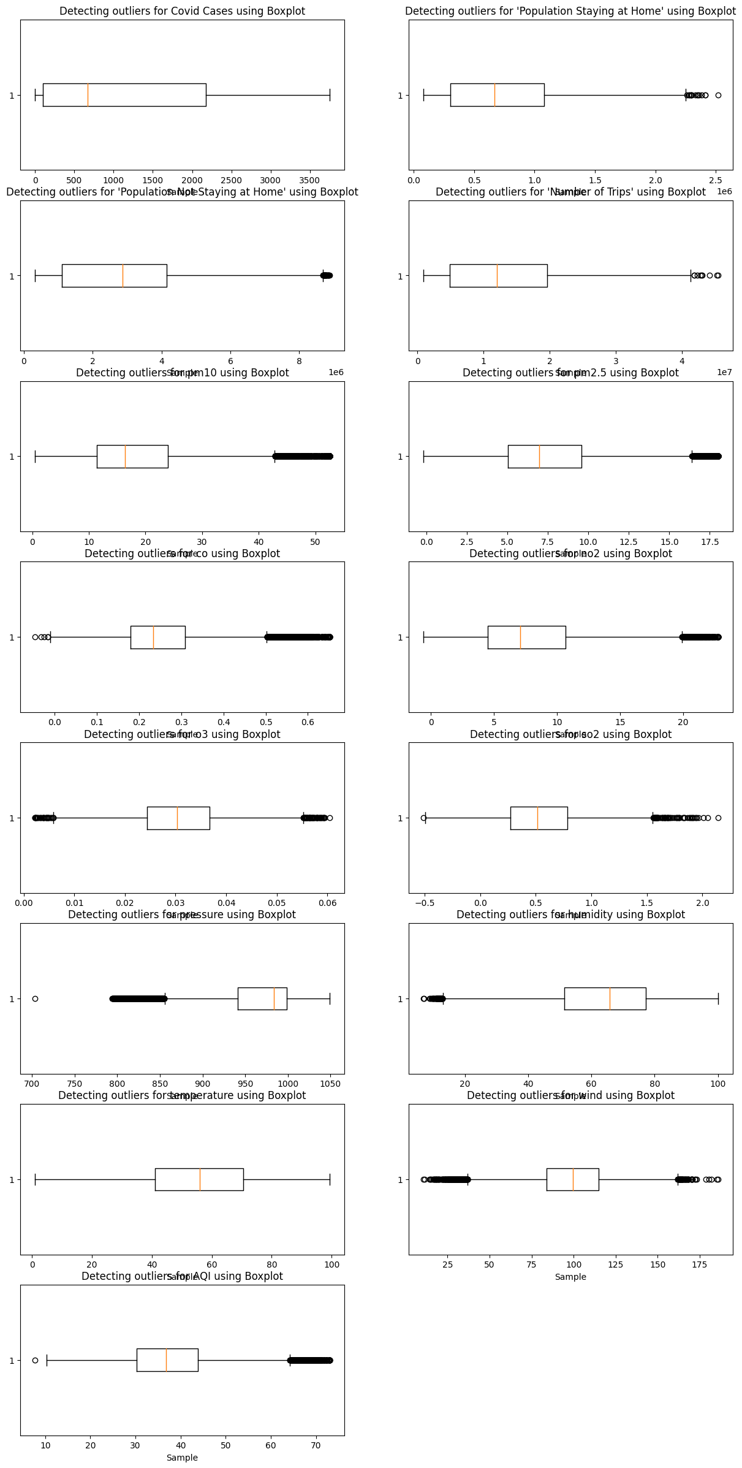**Fig 9 - Outliers detection using Box Plot for dataset - 1**

Outliers were detected using IQR. Criteria is any data point whose Z-score falls out of 3rd standard deviation is an outlier. We have handled the outliers.

**HANDLING OUTLIERS THROUGH QUANTILE BASED FLOORING AND CAPPING:**

**FLOORING AND CAPPING:**

The management of outlier data or instances is known as outlier treatment. Generally, capping/flooring is used to handle outliers.

Capping is the process of replacing a any value greater than upper control limit (UCL) with the UCL value. UCL is determined statistically as

UCL = Q3 + 1.5 * IQR.

The process of flooring involves replacing any value that is less than a particular lower control limit with the LCL value. LCL is determined statistically as

LCL = Q1 - 1.5 * IQR.

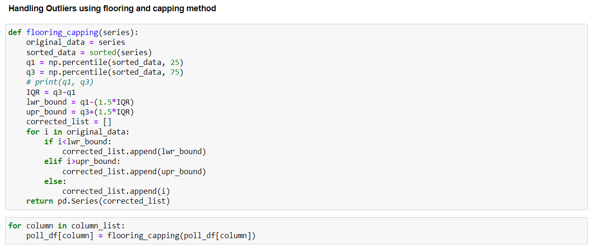**Fig 10 - Handling outliers using flooring and capping method**

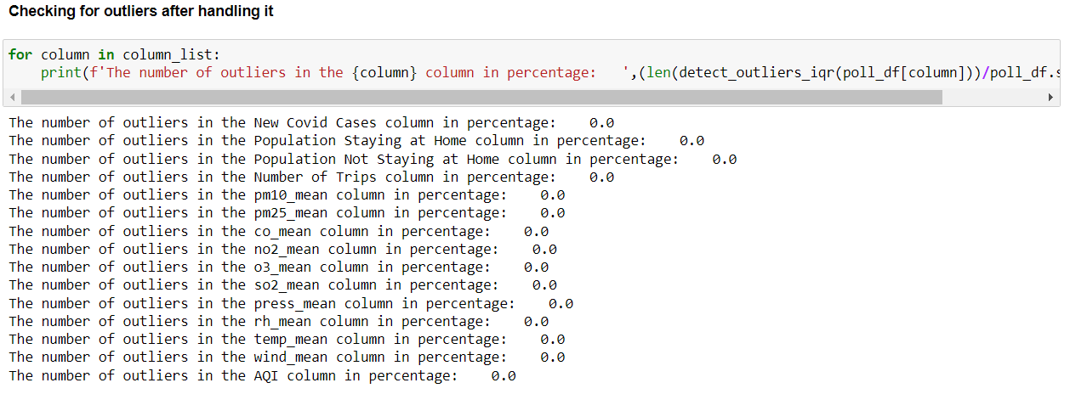**Fig 11 - Percentage of outliers after handling of dataset – 1**

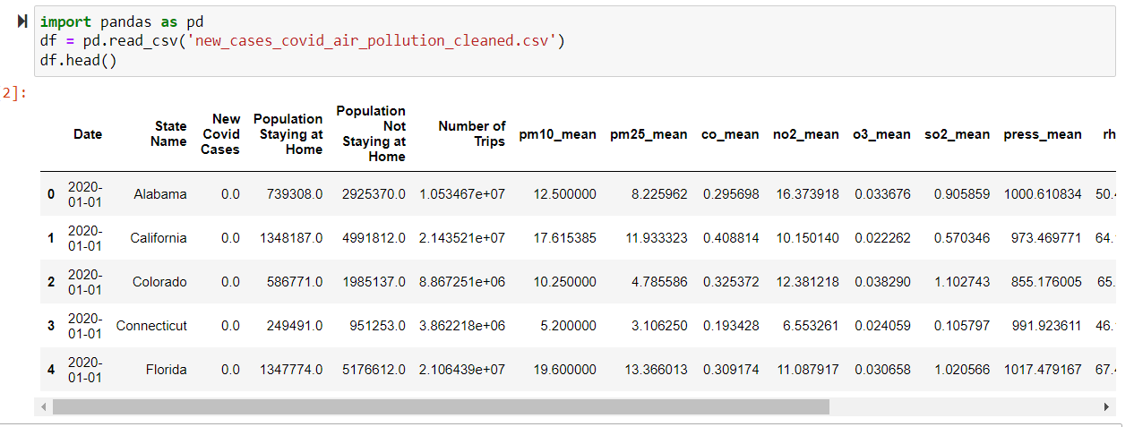

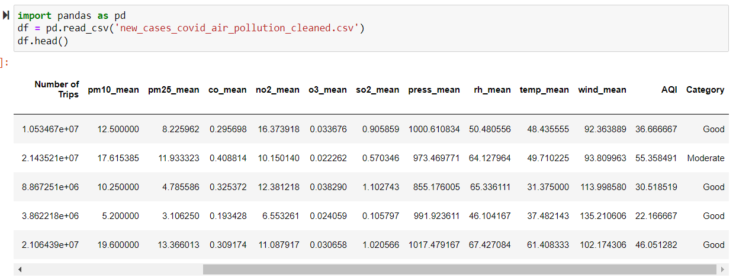 **Fig 12 - Data cleaning of dataset – 1**

**DATASET – 2**: This dataset analyses the prevalence of food insecurity across major demographic categories in the USA. Education, race, state, income, age, marital status, the presence of children, and others are factors that affect food access, but the most important factors for this study are "Enough of the kinds of food wanted”, "Enough Food, but not always the kinds wanted," "Sometimes not enough to eat," and "Often not enough to eat.” We have filtered out the instances with only state codes. We have converted the state codes into names. We have added week wise covid cases to food insecurity dataset.

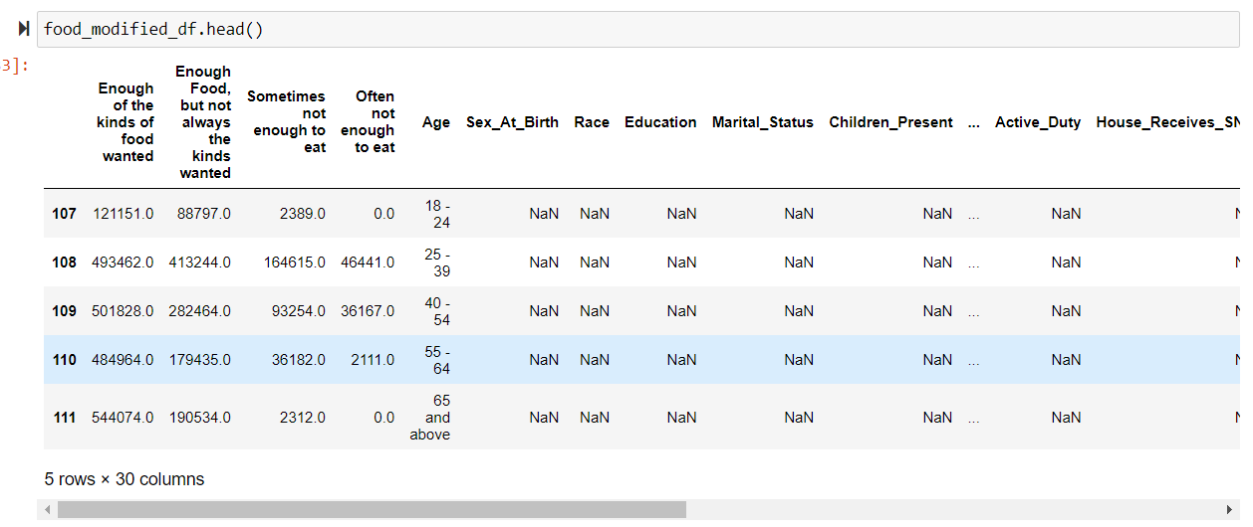

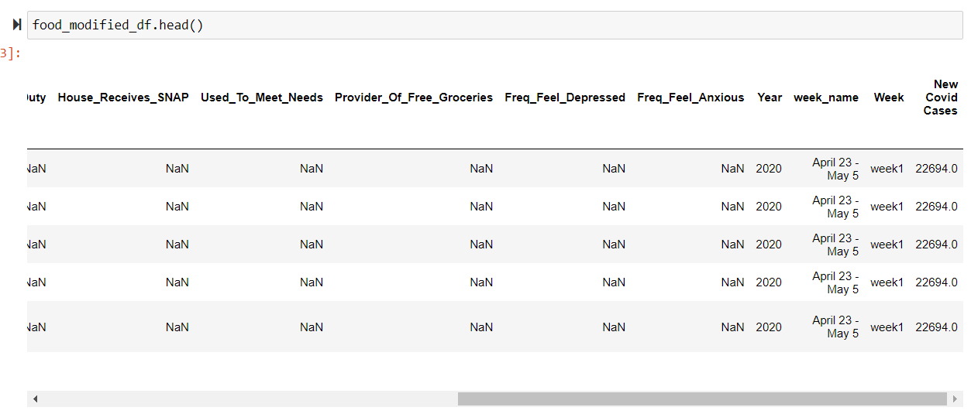**Fig 13 – Dataset after merging of COVID-19 and food insecurity**

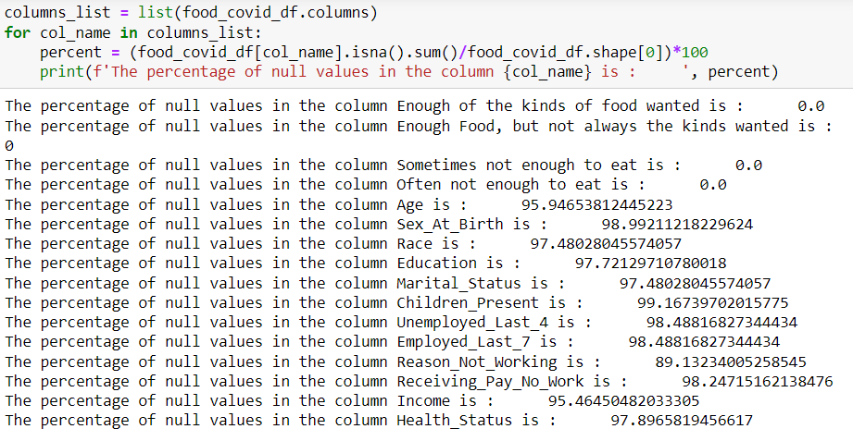

**Fig 14 – Percentage of null values before dropping**

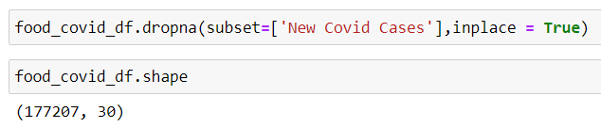

**Fig 15 – Dropping null instances of dataset – 2**

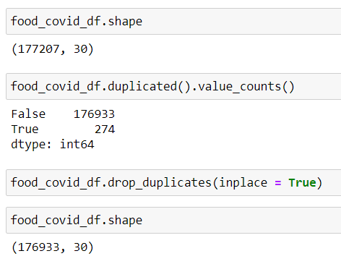

**Fig 16 – Handling of duplicates for dataset - 2**

With the exception of Location, week name, week, and Year, all categorical columns have a null value percentage of somewhat larger than 90%, making it impossible to impute categorical variables from the aggregated data. We dealt with the duplicates and discarded the null instances. We utilized a box plot to look for outliers. We can do an outlier's test between each category variable and its dependent variables (enough of the kinds of food wanted, enough food, but not always the kinds wanted, sometimes not enough to eat, often not enough to eat), but we can only do so for the New Covid Cases column. The new COVID cases column does not contain any outliers.

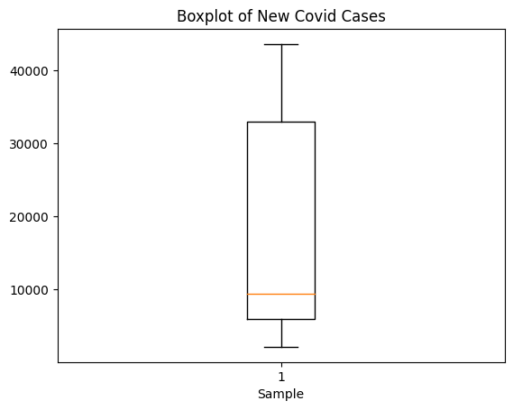

**Fig 17 - Outlier detection for New covid cases**

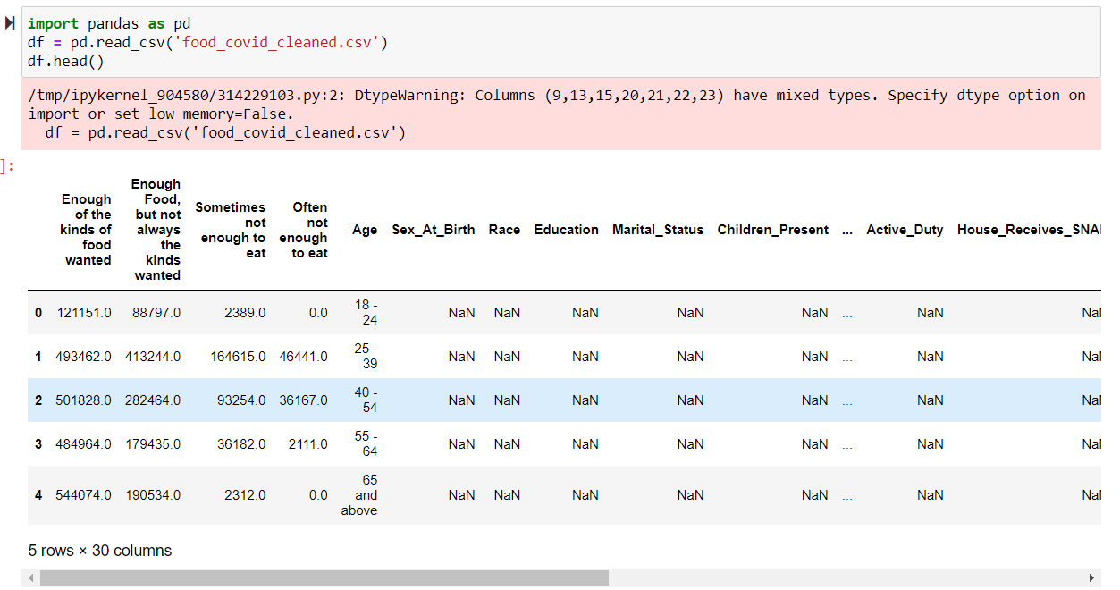

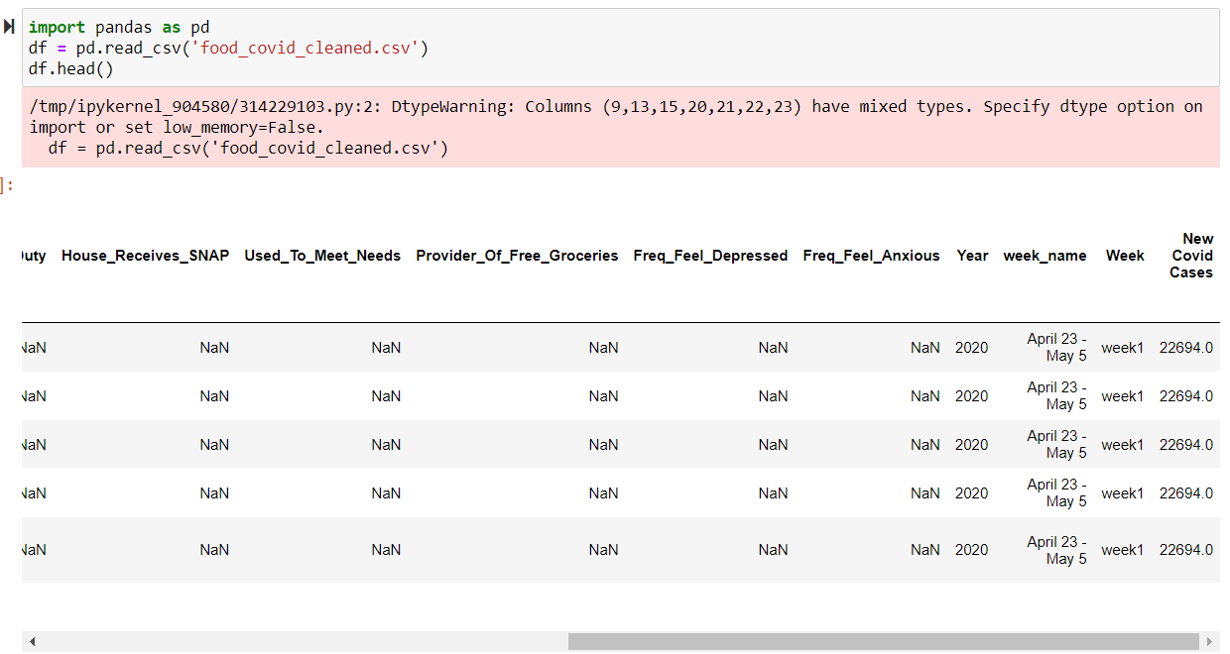**Fig – 18 Data cleaning of dataset – 2**

**5** **DATA ANALYSIS**

Data cleansing, modification, and structure are all aspects of Python data analysis that help to reveal information that may be used to evaluate a company. The two main purposes of data analysis are to extract information that may be used and to make decisions, which are also based on the analysis. Descriptive statistics, association hypothesis testing, and supervised learning are the three components of data analysis and visualization. The essential characteristics of data in research are described using the Python Descriptive Statistics procedure.

**5.1** **Descriptive Statistics**

**5.1.1** **Statistical Data Distributions**

The term "distribution" simply refers to the gathering of information or scores on a variable. To determine if the distribution is normal or not, this is performed. It has two potential outcomes. The distribution's mean is its anticipated value. In general, the variance describes how far off observations are from the mean.

Variance = Mean + Standard deviation.

**EXPLORATORY DATA ANALYSIS FOR DATASET – 1**

The primary elements of data exploration are:

1. Knowing your variables is step one

2. Keeping your dataset clean

3. Examining relationships between various factors

We have used several visualization techniques such as pair plot, point plot, line plot, bar graphs, histograms, box plots, p, pie charts, scatter plot, and regression plot included few of them here.

**Pair plot using seaborn:** The pairwise association between different variables in our dataset is understood using a pair plot, which is a matrix of scatterplots. For the pair plot visualization, we utilized the seaborn library.

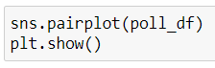

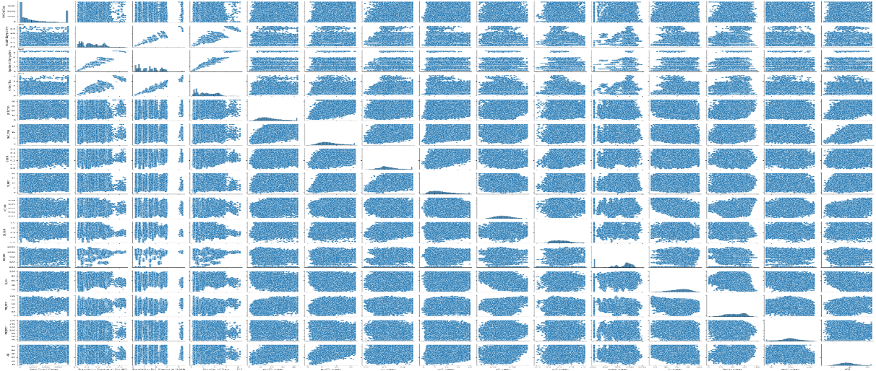

**Fig 19 – Pair plot using seaborn**

The frequency distribution is shown via histogram. The best way to depict the distribution of numerical data is with this technique. So, we chose histogram as one of the methods to represent the distribution.

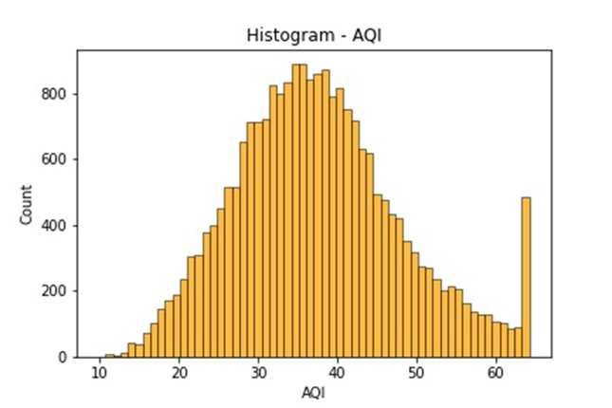 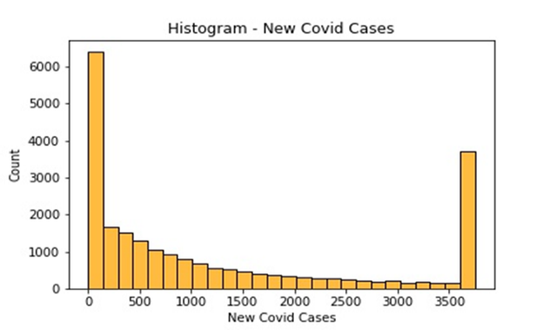

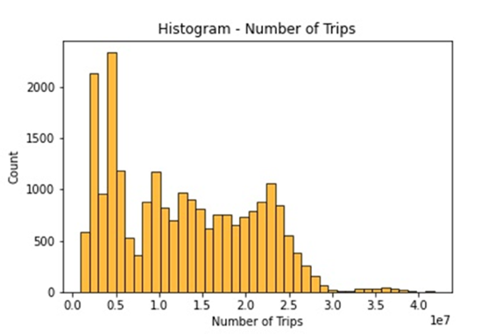 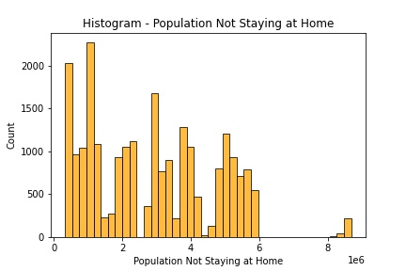

**Fig 20 - Histograms for univariate continuous variables of Air pollution dataset**

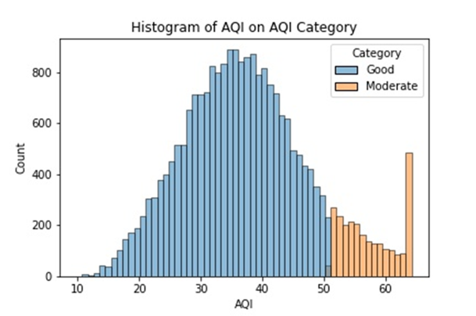 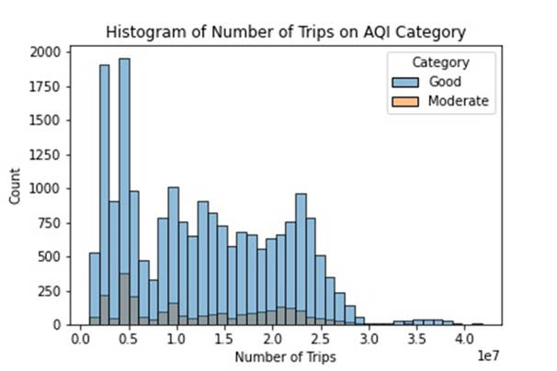

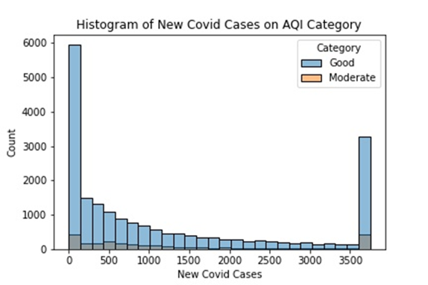 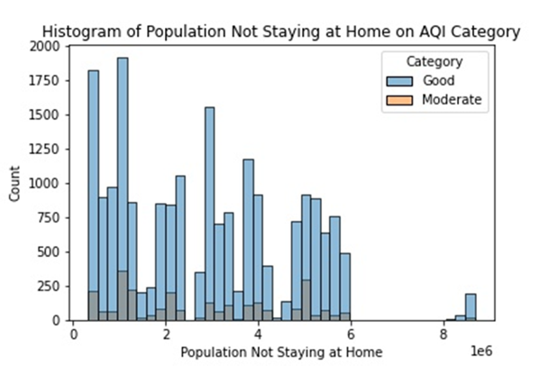

**Fig 21 – Histogram plot showing frequency of good and moderate air quality**

From the above plots we can see that number of instances for good category of AQI is higher than the moderate AQI, which indicates unbalanced dataset.

**BOX PLOT**: A box plot is a visual representation of groupings of numerical data through their quartiles. With a line at the median, the box contains the data's Q1 through Q3 quartile values (Q2).

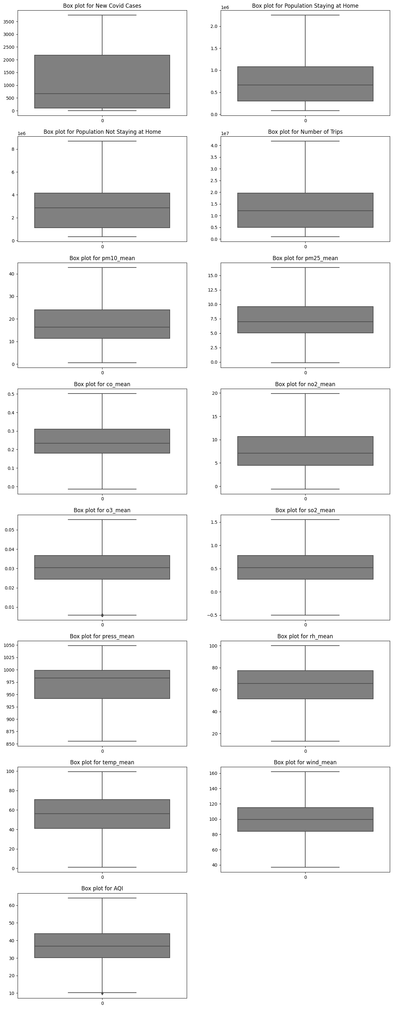 **Fig 22 – Box plots for continuous variables**

Most often, line plots are used to show how one or more data points have changed direction over time.

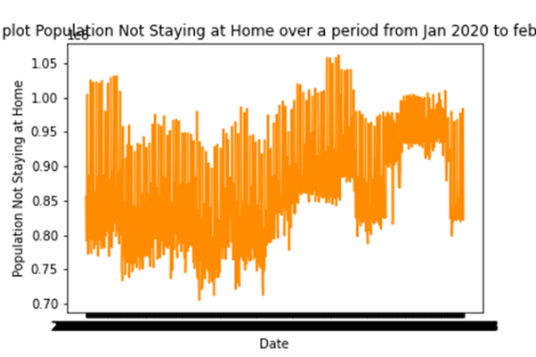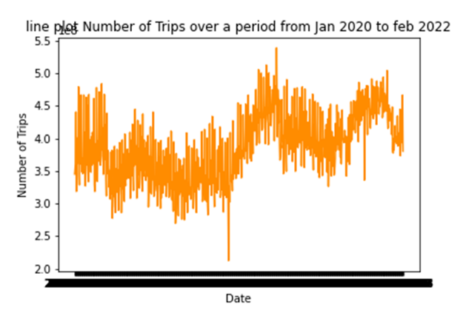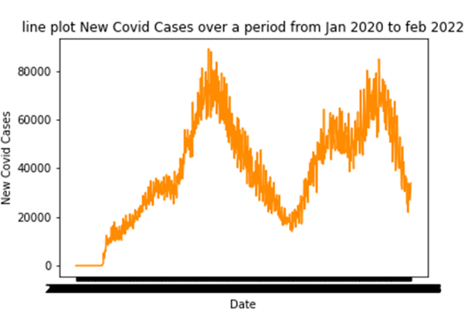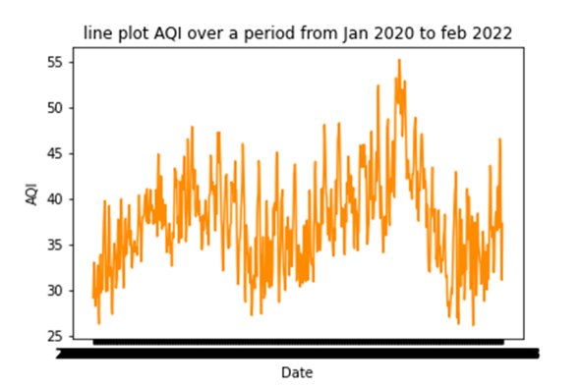**Fig 24 – The trend of continuous variables using line plots with its mean values**

From the new covid cases and AQI line plot we can infer that there was approximately similar trend over the period from 2020 to 2022

Analysing two variables simultaneously is known as bivariate analysis. It is used to establish the existence, strength, and importance of any relationships or discrepancies between two variables is bivariate analysis.Each data point is depicted by a dot in a scatter plot, which is a visual representation in scatter plot.

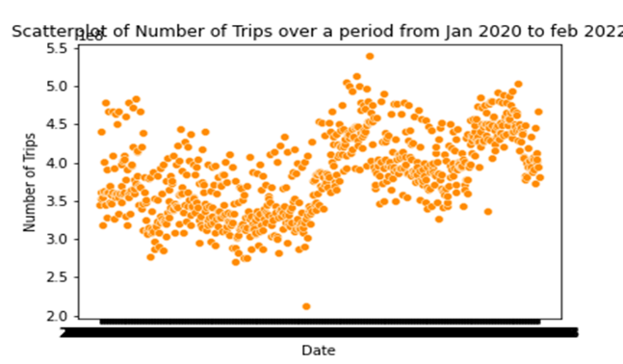 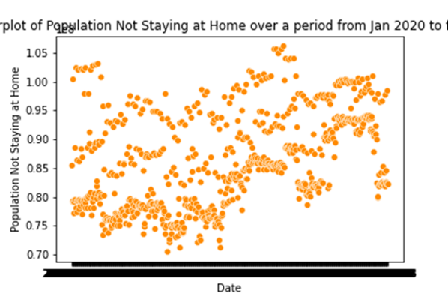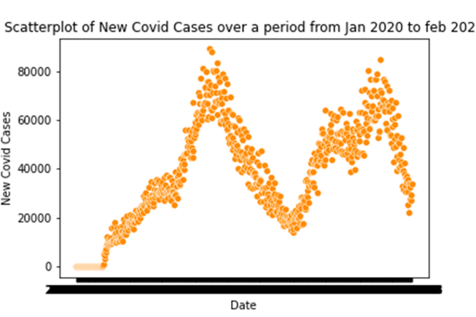 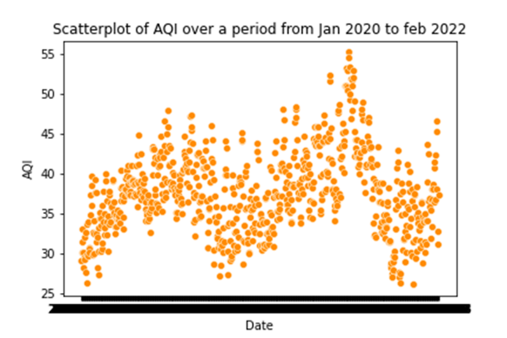

**Fig 25 - The trend of continuous variables using scatter plots with its mean and maximum values**

During regression, connections between variables are sought. By generating a regression line between two parameters, it makes it easier to see how linearly related they are.

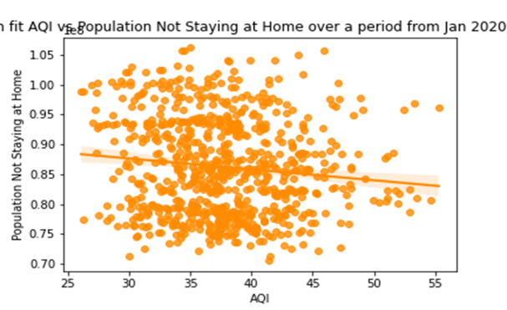 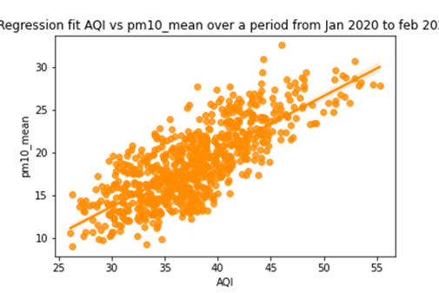

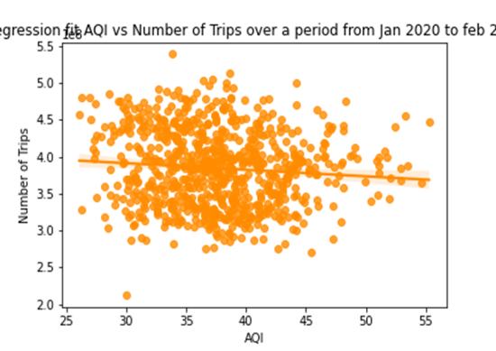 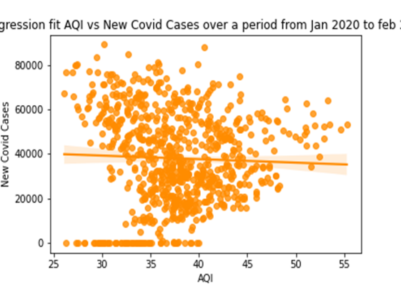 **Fig 26 – Regression plots of AQI vs other continuous independent variables**

Regression plot of pm10 and AQI indicates that there is positive correlation among them, which says that increase in the pm10 value increases the AQI value. For New Covid Cases and AQI, there is no strong correlation as its value is 0.03

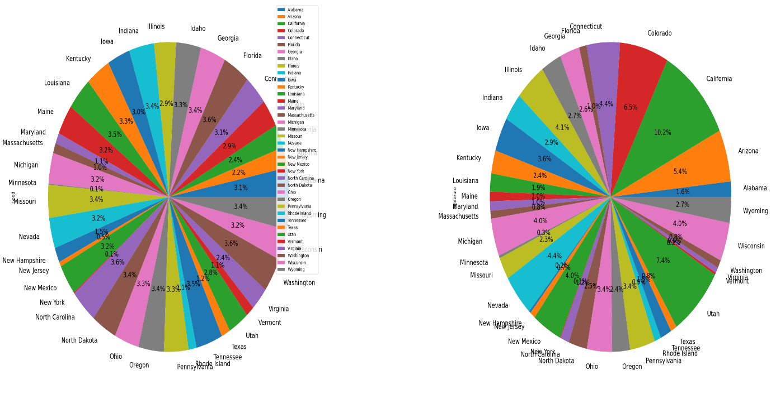**Fig 27 - Grouped bar charts of AQI state-wide (left – Good, right-Moderate)**

**EXPLORATORY DATA ANALYSIS FOR DATASET – 2**

We have used bar plots and line plots for this dataset.

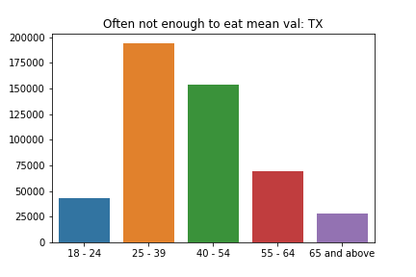 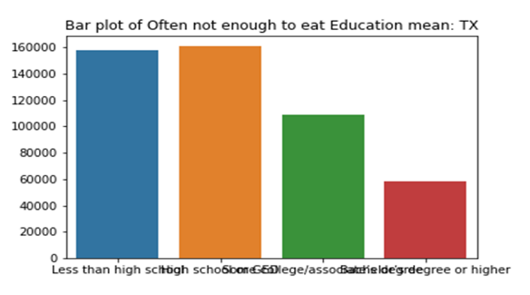

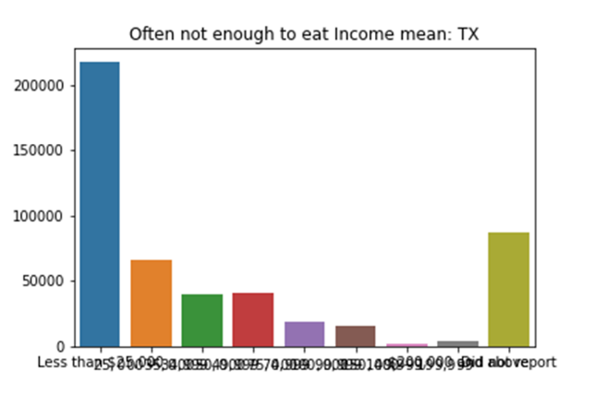 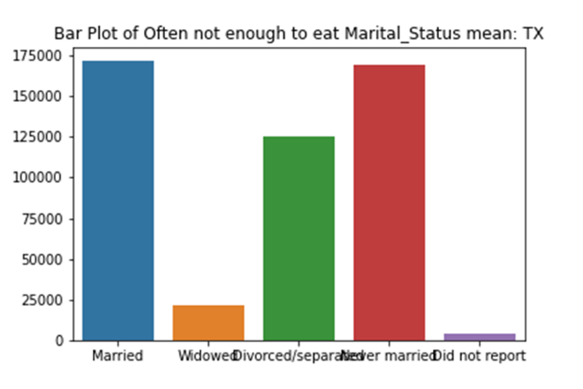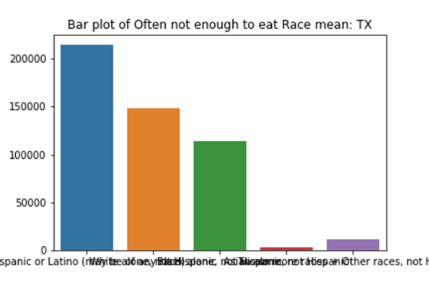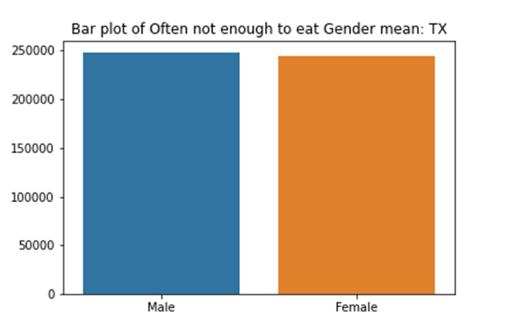

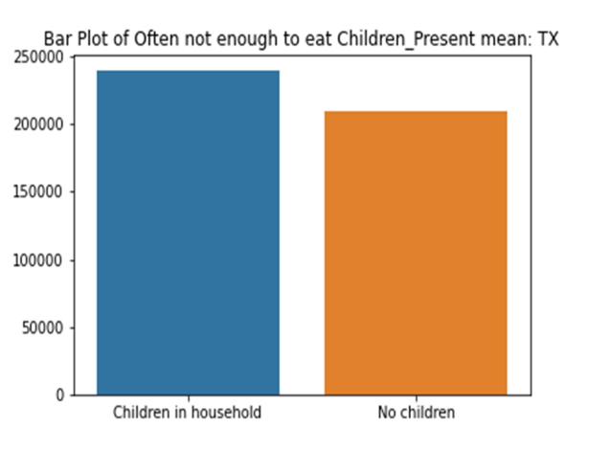

**Fig 28 - Bar plots of categorical variables with mean value of dependent variable for Texas**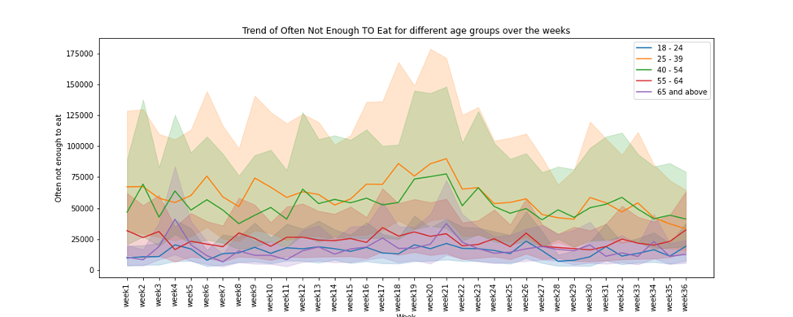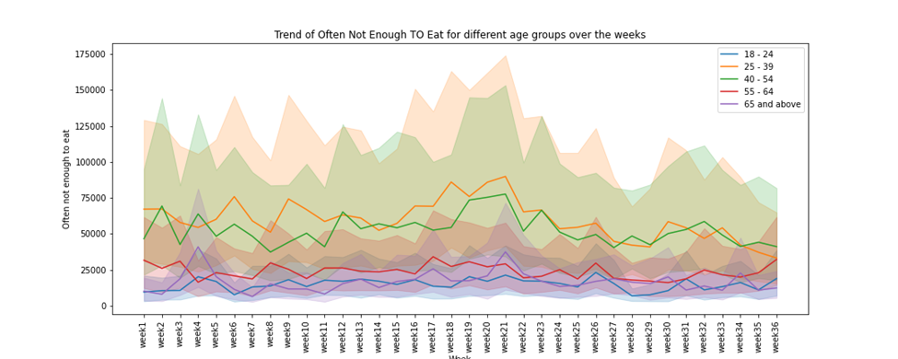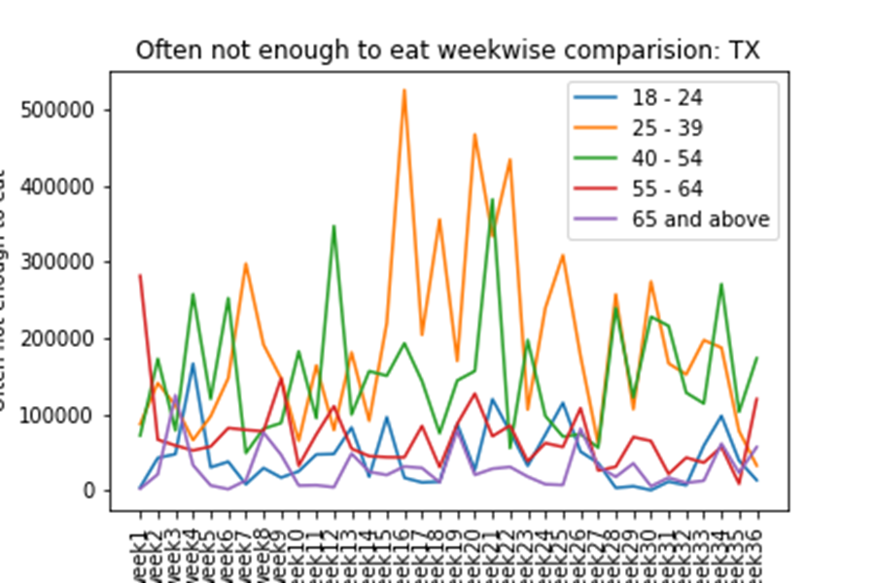

**Fig 29 - Line plot of continuous dependent variables by independent categorical variables over a period**

**5.1.2** **Normality Test and Shapiro test**

Both these tests were used to measure whether the dataset is normally distributed or not.

**DATASET – 1:**

**NORMALITY TEST:**

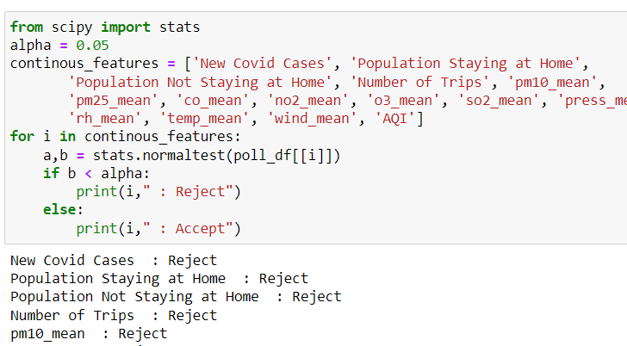 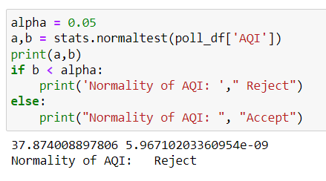

**Fig 30 – Normality test for dataset – 1**

**SKEW TEST:**

When a probability distribution is not perfectly symmetrical, skew tests are performed to identify the asymmetry. The resultant graphic, called skewness, which displays the magnitude and direction of skew from horizontal symmetry, is the outcome of examining the normalcy of a particular dataset. A model's capacity for forecasting can be significantly impacted by the skewness of the data distribution.

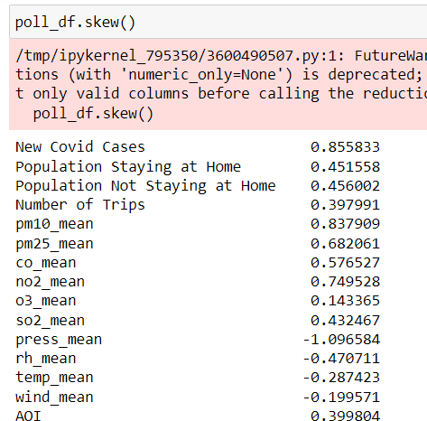 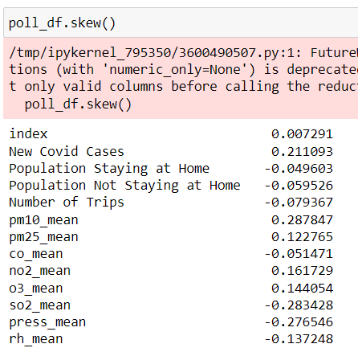  **Fig 31 – Skew test for dataset – 1**

As the skewness is high square rot and boxcox functions were used to reduce it. With the Box Cox approach, non-normal dependent variables are given a normal form. It would make it feasible to perform more tests than would otherwise be practicable.

 The output after box cox is the 2nd image where it has been reduced to moderate from high.

1. The variables with skewness > 1 are highly positively skewed.
2. The variables with skewness < -1 such as press mean are highly negatively skewed.
3. The variables with 0.5 < skewness < 1 such as New Covid Cases, pm10_mean, pm25_mean, co_mean, no2_mean is moderately positively skewed.
4. The variables with -0.5 < skewness < -1 are moderately negatively skewed.
5. And the variables with -0.5 < skewness < 0.5 are symmetric i.e., normally distributed

**SHAPIRO TEST**

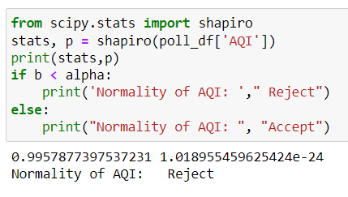

**Fig 32 - Shapiro test for dataset – 1**

**DATASET – 2:**

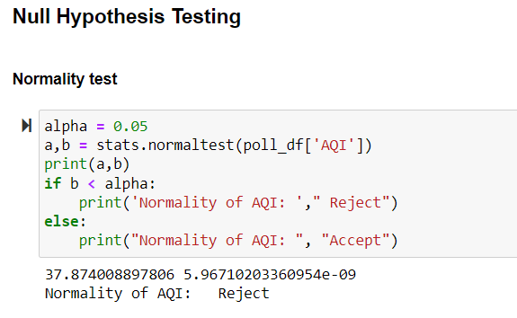

**Fig 33 - Normality test for dataset - 2**

**SKEW TEST:**

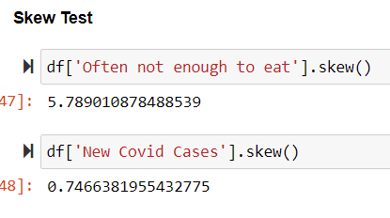

**Fig 34 – Skew test for Continuous values in a dataset - 2**

**SHAPIRO TEST:**

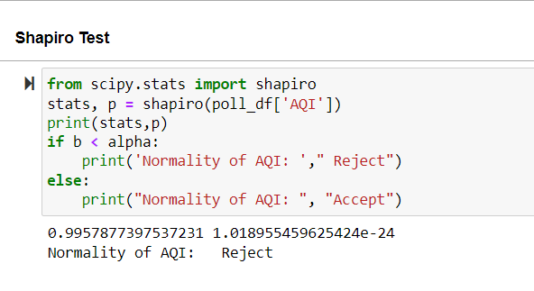

**Fig 35 - Shapiro test for data set - 2**

**5.1.3** **visualization**

Python Seaborn and Matplotlib were used for data visualization.

**5.1.3** **Correlation Among Attributes**

**DATASET -1**

CORRELATION HEAT MAP: The use of correlation analysis can help determine if specific qualities are appropriate for use in linear regression or other modelling techniques. A visual representation of values using colour differentiation is called a heat map. Python's heat maps are a special kind of graph that show various colour tones to distinguish between the values in the graph. The lighter colours denote lower values, whereas the darker hues denote higher values.

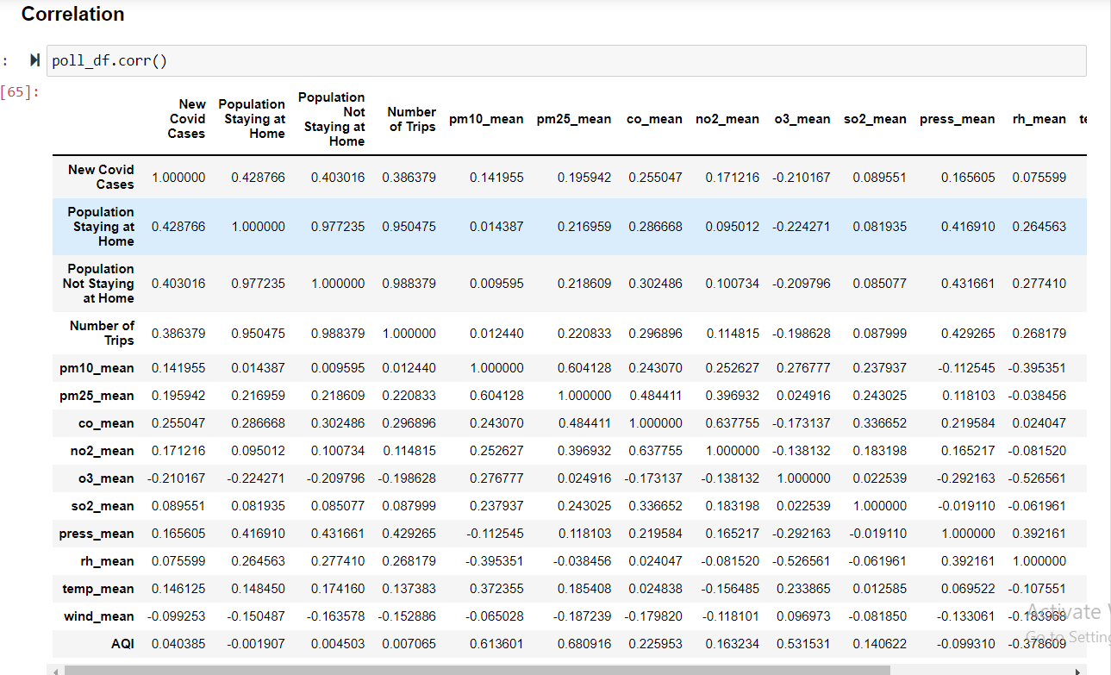

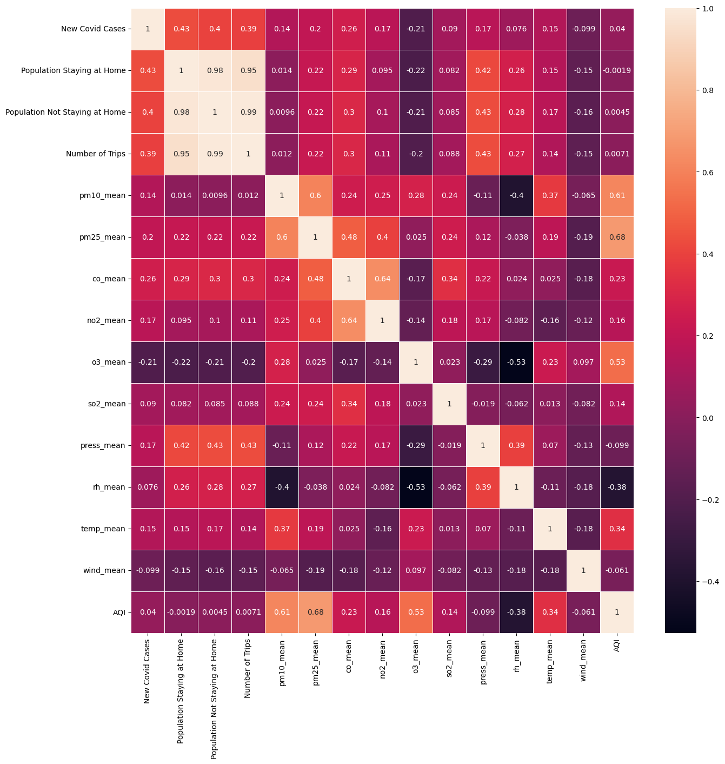**Fig 36 - Correlation heat map of dataset -1**

From the above figure, an infer that pm25_mean has the highest correlation of 0.680916 with the AQI followed by the pm10_mean. And for the new covid cases, Population Staying at Home has the highest correlation of 0.428766, followed by the Population Not Staying at Home with a value of 0.403016. A positive correlation indicates that the extent to which those variables increase or decrease in parallel; a negative correlation indicates the extent to which one variable increases as the other decreases.

**DATASET –2**

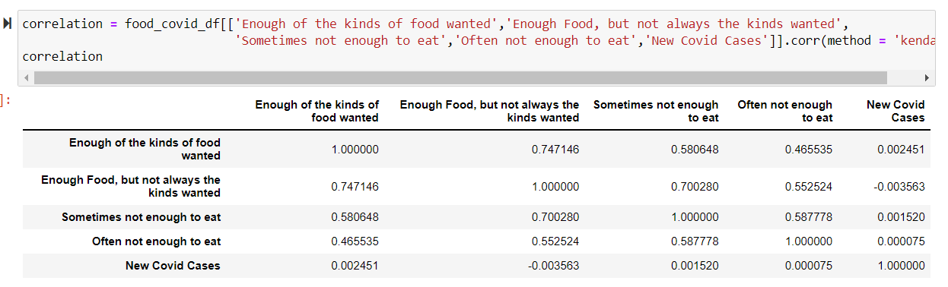

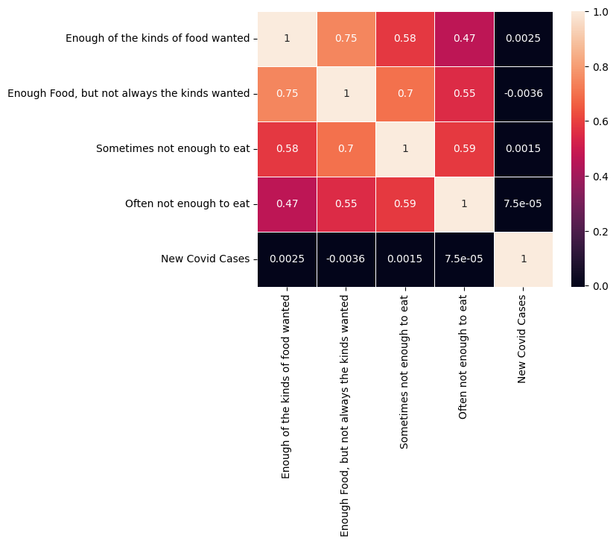**Fig 37 - Correlation heat map of dataset -2**

**5.2** **Hypothesis Testing**

Experimental data analysis techniques include statistical testing. The two types of testing are parametric and non-parametric tests. Parametric tests are used with regularly distributed data, whereas non-parametric tests are used with normally distributed data.

H0: Covid has no impact on the Air pollution.

H1: Covid has an impact on the Air pollution.

**5.2.1** **Mann and Whitney U test, Kruskal Wallis Test, Levene’s Test**

The Mann and Whitney U test is employed to determine whether there are any differences between two independent samples when sample sizes are small and sample distributions are non-normal. The two-sample independent t-test is assumed to be its nonparametric equivalent**.**

**DATASET -1 (Testing Null hypothesis):**

To perform the null hypothesis which is covid cases has no impact on the Air pollution. Here covid cases are grouped into two categories which are “less than mean covid” and “Greater than mean covid” and passing the corresponding ‘AQI’ values to Mann and Whitney U test.

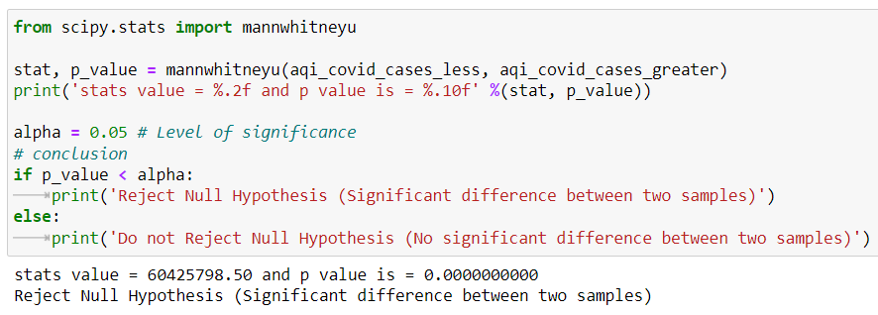**Fig 38 - Mann Whitney U test for testing Null hypothesis**

Null hypothesis is rejected as there is a significant difference between both the samples. The P values states that null hypothesis can be rejected indicating there is an impact of COVID 19 on USA air pollution.

**POST HOC TEST for Null Hypothesis Air pollution:**

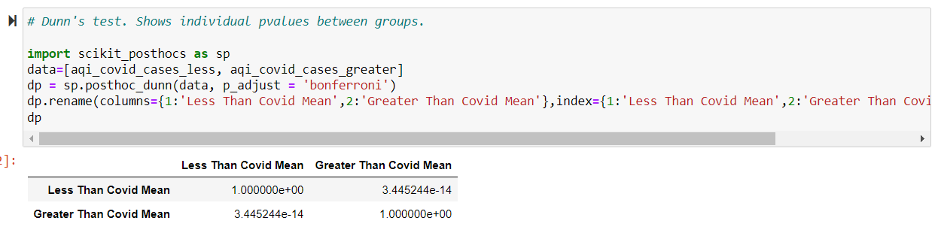**Fig 39 - Post HOC method for covid cases vs AQI**

p-value, which is less than 0.05, we can reject the Null Hypothesis stated and say that Covid Cases has an impact on USA Air pollution (AQI).

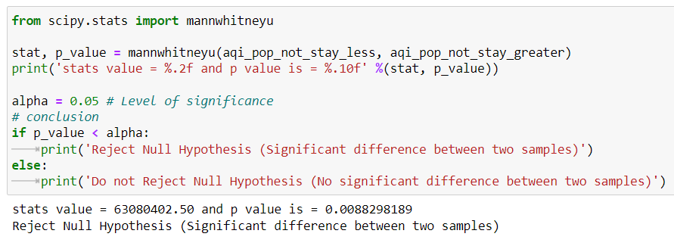 **Fig 40 - Hypothesis testing for population Not staying at home**

The P values states that null hypothesis can be rejected indicating there is an impact of population not staying at home on USA air pollution.

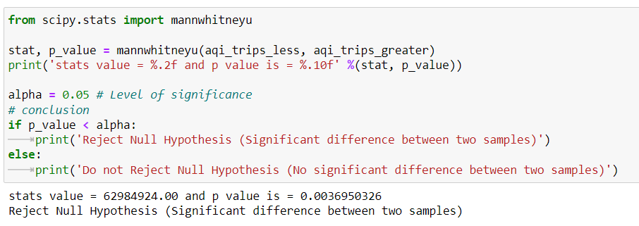**Fig 41 - Hypothesis testing for Number of Trips**

The P values states that the null hypothesis can be rejected indicating there is an impact of number of trips on USA AQI.

**DATA SET – 2 (Food insecurities Dataset)**

H0: Covid has no impact on the USA food insecurities

H1: Covid has impact on the USA food insecurities

Out of four dependent variables - ("Enough of the kinds of food wanted", "Enough Food, but not always the kinds wanted", "Sometimes not enough to eat", "Often not enough to eat"), we considered "Often not enough to eat" because it indicates the huge impact of covid on food Insecurity.

**5.2.3** **Levene’s test**

To confirm that variances are equal amongst all samples, we applied Levene's test**.**

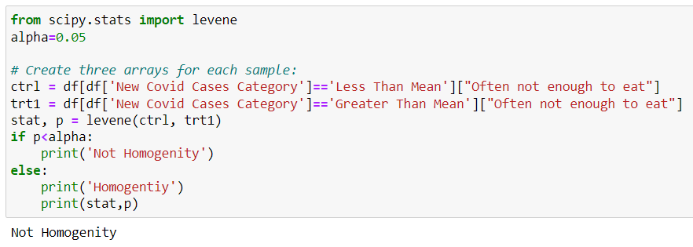**Fig 42 – Levene’s test for 'often not enough to eat’ for age group**

The distribution does not have homogeneity, cannot perform parametric tests

**5.2.2** **Kruskal Wallis test- Testing Null hypothesis**

In place of the One-Way Anova, the Kruskal-Walli's test is a non-parametric test that may be employed. Since the "Often not enough to eat" category column for Covid instances is not typically distributed and is not homogeneous. We thus employ non-parametric testing. In order to determine the overall impact of Covid on the USA, we include all 50 states in the test. We test the null hypothesis by considering the “age” and “often not enough to eat” variables to test whether covid has an impact on food insecurities. Similarly, we can perform for other categorical variables.

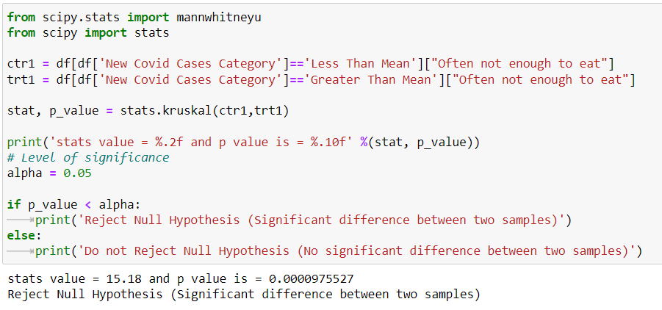**Fig 43 – Kruskal Wallis test for age group**

From the above results we got p value less than 0.05, we rejected the null hypothesis and state that covid has a significant impact on the USA food insecurities.

**5.3** **Supervised Learning/Machine Learning**

**MODEL BUILDING DATASET 1 (Air pollution)**

An algorithm is trained to find patterns in a dataset as part of the machine learning process known as supervised learning. In supervised learning, a model is created first, then performance analysis utilizing various techniques is performed out of which Random Forest Regression using Random search after SMOTE has got the highest accuracy.

Different types of linear regression are performed. Multiple linear regression, support vector linear regression, decision tree and random forest. These linear regressions were performed before and after SMOT technique.

**K cross fold validation** is a method of splitting the data that enables to create a more generic model by making better use of the information. Any kind of machine learning seeks to build a model that is more broadly applicable and capable of performing well on data that has not yet been observed. Data splitting could be carried out more efficiently with k-fold cross-validation. Finding the most viable set of hyper-parameters for the model to get the maximum accuracy is done using the **grid searching** approach.

Out of all the Machine learning regression models that we performed; Random Forest has the highest R-squared value which is 0.94 after SMOTE and Random Search.

**5.3.3.1** **Random Forest**

The supervised learning approach known as Random Forest employs several Decision Trees and an ensemble learning mechanism.

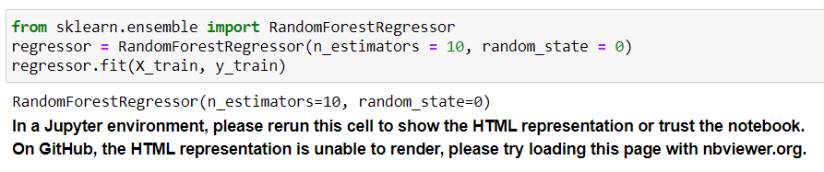 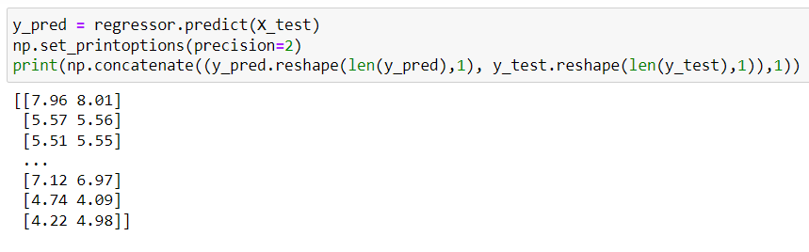 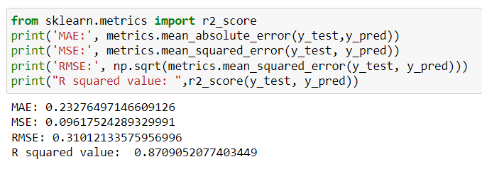**Fig 44 – Random Forest results for data set –1**

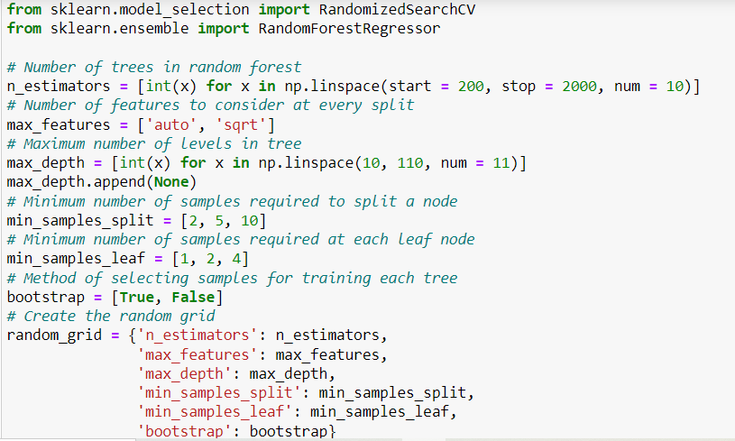

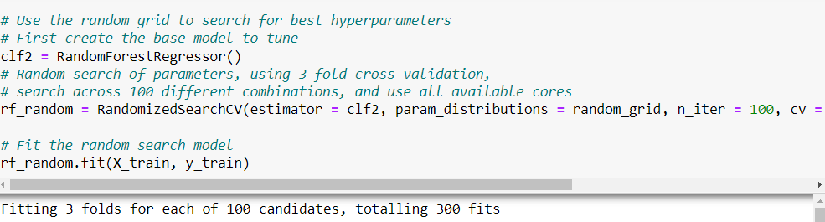

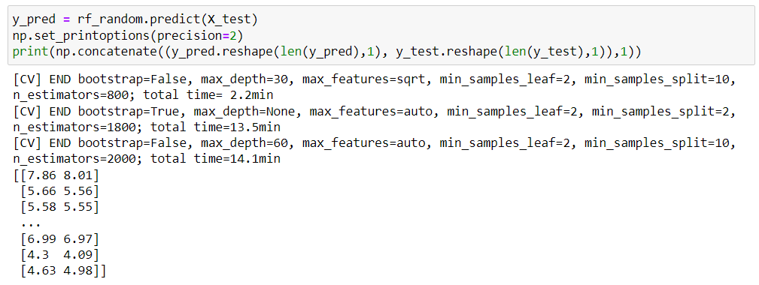

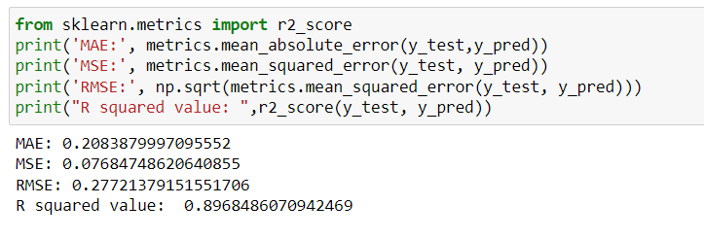

**Fig 45 – Random Forest using K fold validation and grid search for data set –1**

**SMOTE ANALYSIS:(synthetic minority oversampling technique)**

One of the most popular oversampling techniques for addressing the imbalance issue is SMOTE.

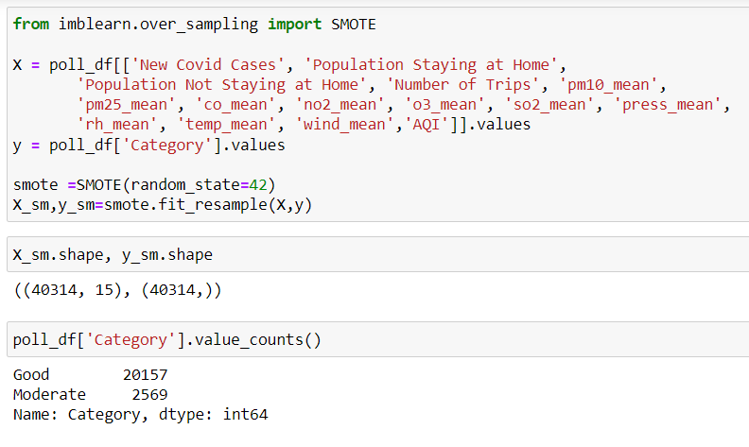 **Fig 46 – Applying SMOTE analysis or dataset - 1**

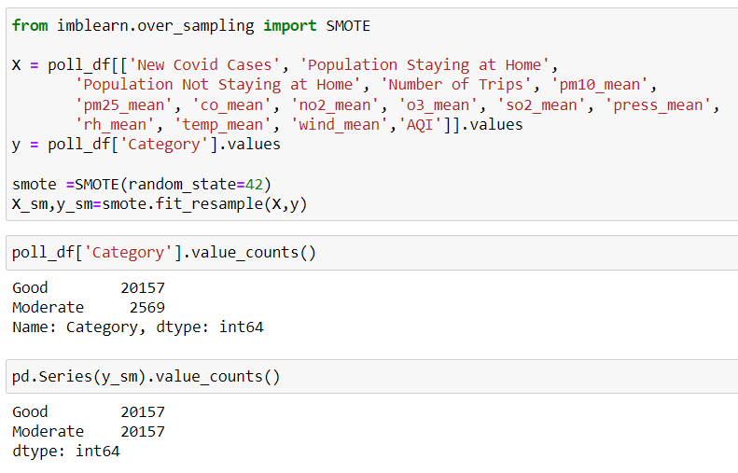

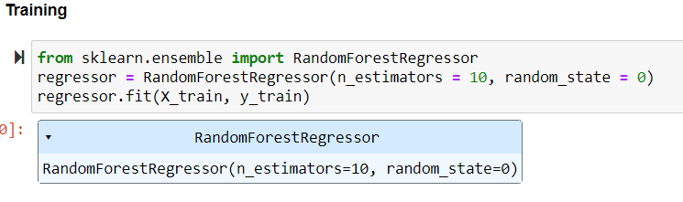

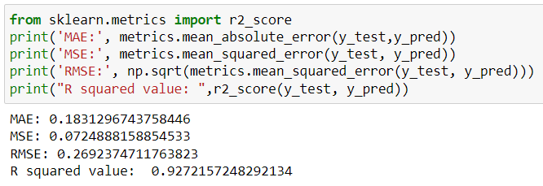

**Fig 47 - Random Forest results for data set –1 after SMOTE**

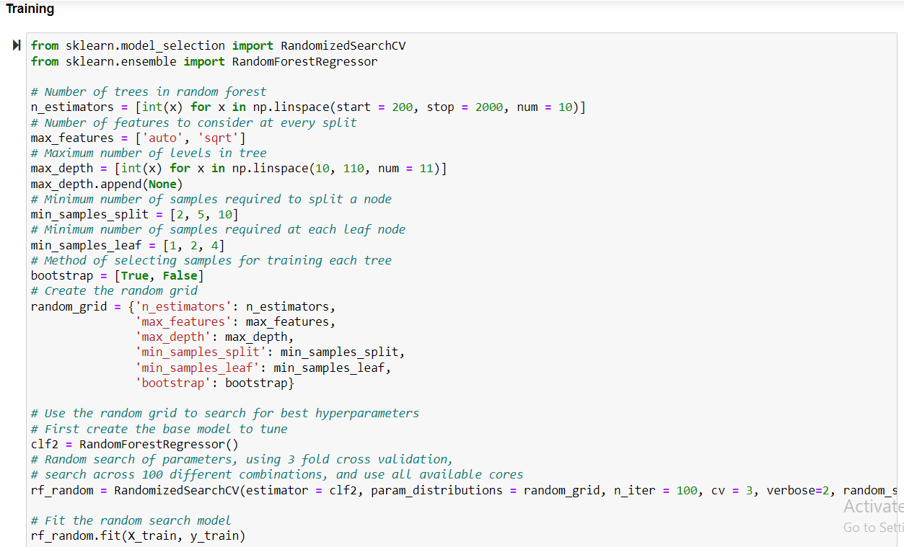

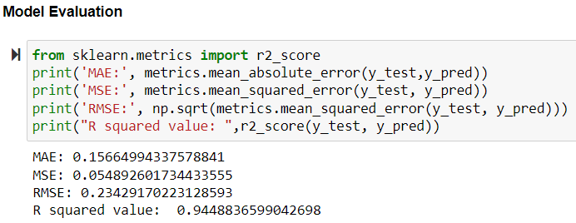

**Fig 48:** **Random Forest using K fold validation and grid search results for data set –1 after SMOTE**

**CLUSTERING:**

Data grouping or clustering is accomplished using a variety of ways. As a set of data objects that are more similar to one another than to data objects in other clusters, clusters can be broadly defined as such. One can use silhouette analysis to determine whether the data set has any outliers or whether the clustering procedure hasn't functioned successfully. To do this, it is possible to compare and analyse the values of each spot's Silhouette. If one or more points have values much lower than the other points, there may be a problem with the algorithm or an outlier in the dataset. We found out the optimized K value using Silhouette Method. From this method, the optimal value of k=2.

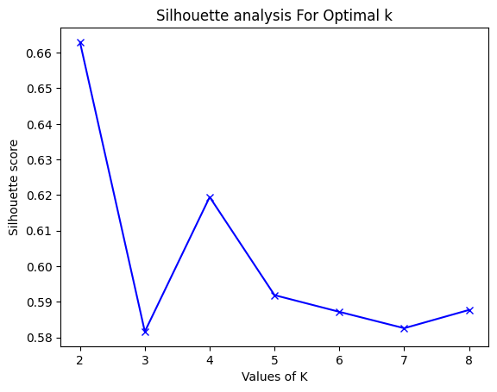

**Fig 49 – Silhouette analysis for dataset – 1**

From Silhouette Method, the optimum value of K is 2

**K MEANS CLUSTERING BEFORE SMOTE:**

Unsupervised machine learning techniques for finding groups of data items in a dataset include the k-means clustering algorithm.

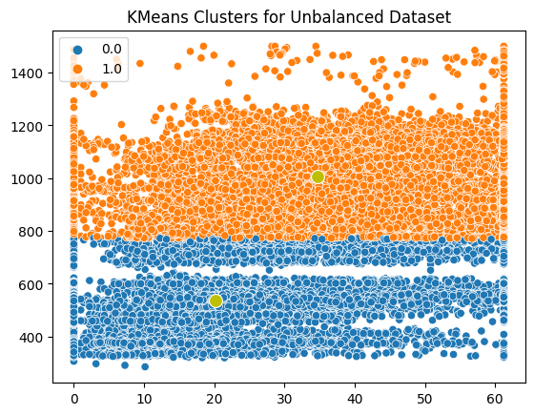

**Fig 50 – K means clustering for dataset – 1 before SMOTE**

**K MEANS CLUSTERING after SMOTE:**

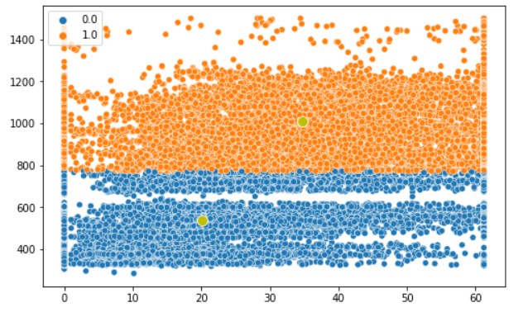

**Fig 51 – K means clustering for dataset – 1 after SMOTE**

**HIERARCHIAL AGGLOMERATIVE CLUSTERING:**

In a bottom-up clustering method known as hierarchical clustering, clusters have sub-clusters, which have sub-clusters, and so on. Each component of the cluster is first identified, and these atomic clusters are then combined to form higher and higher clusters until a specified number of items are contained within a single cluster or a specific termination condition is required.

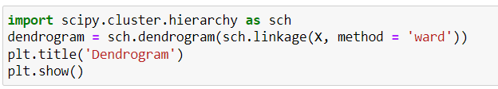 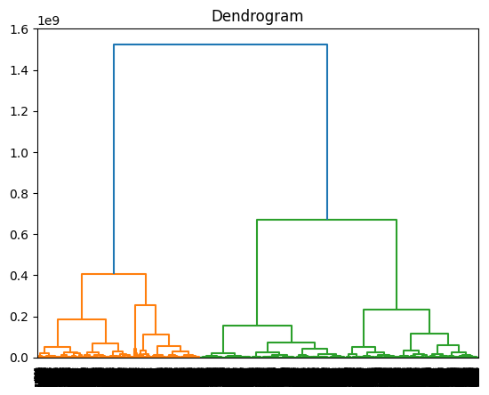

**Fig 52 – Hierarchical agglomerative clustering representation using a dendrogram**

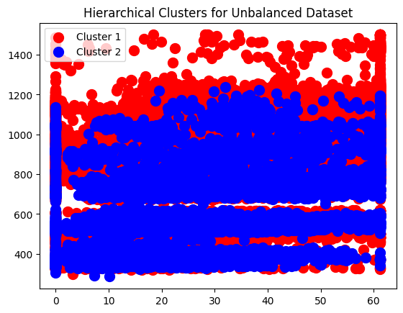

**Fig 53 – Hierarchical clustering for Unbalanced data set – 1**

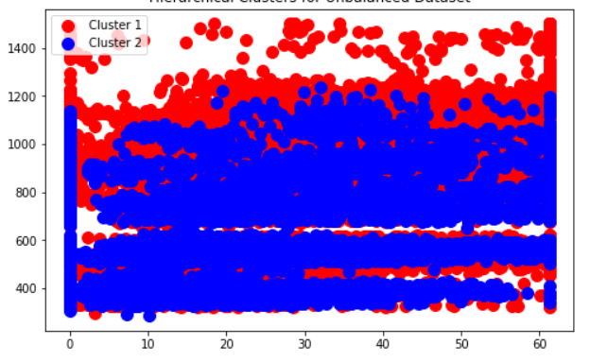

**Fig 54 – Hierarchical clustering for balanced data set – 1**

**Clustering Visualisation before and after smote:**

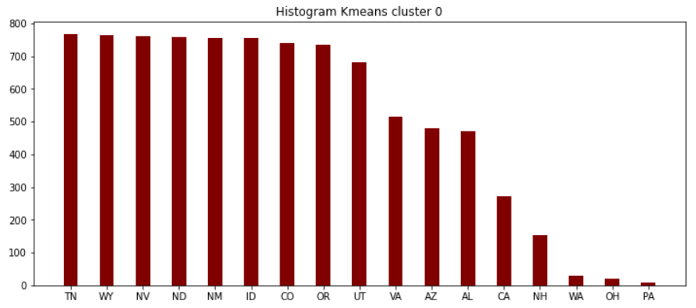

**Fig 55 – Histogram for K-means cluster 0 for unbalanced dataset – 1**

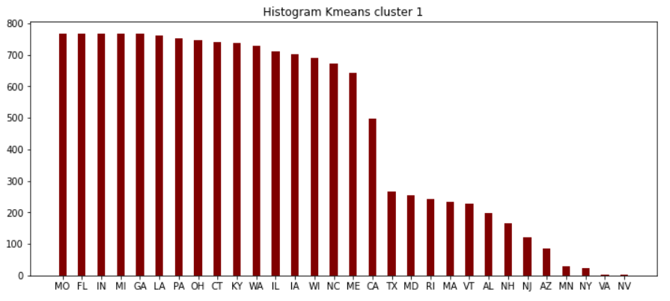

**Fig 56 -** **Histogram for K-means cluster 1 for unbalanced dataset – 1**

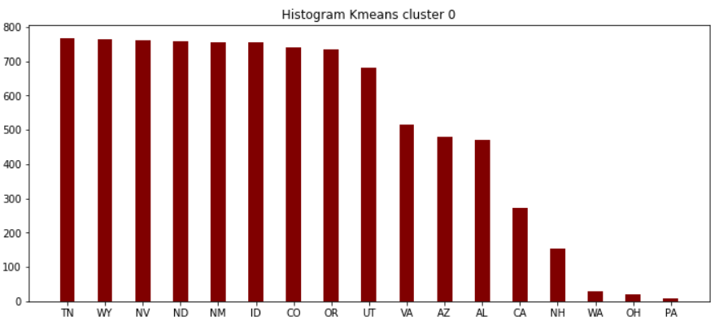

**Fig 57 – Histogram for K-means cluster 0 for balanced dataset – 1**

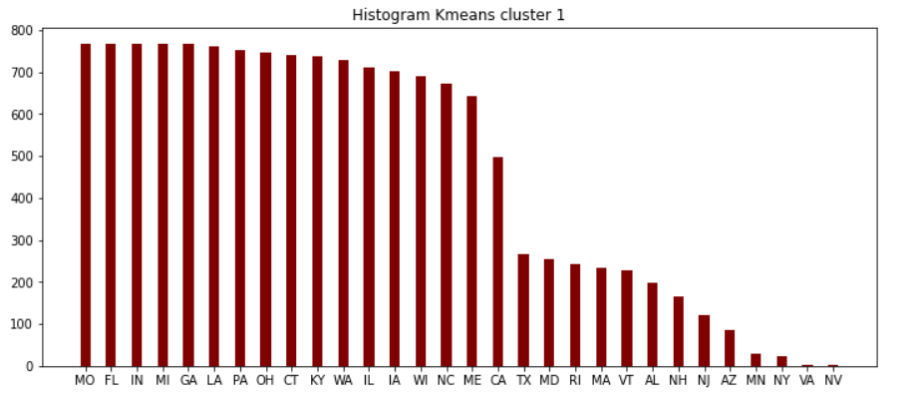

**Fig 58 – Histogram for K-means cluster 1 for balanced dataset – 1**

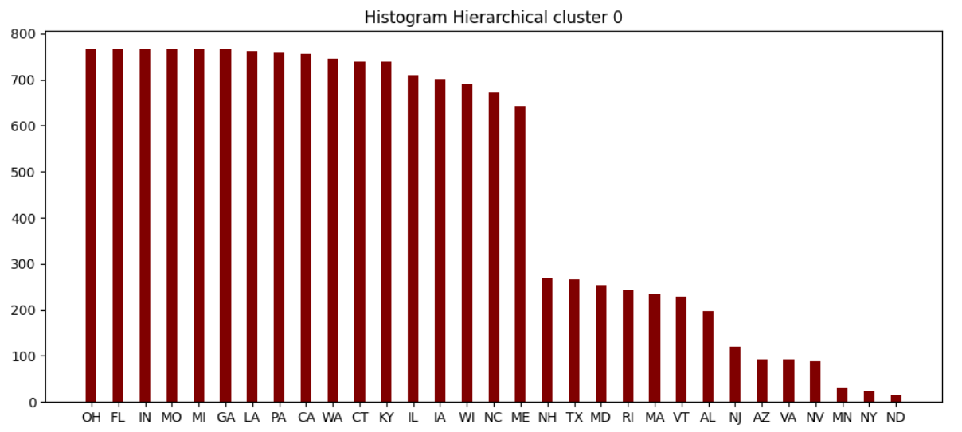

**Fig 59 – Histogram for Hierarchical cluster 0 for unbalanced dataset – 1**

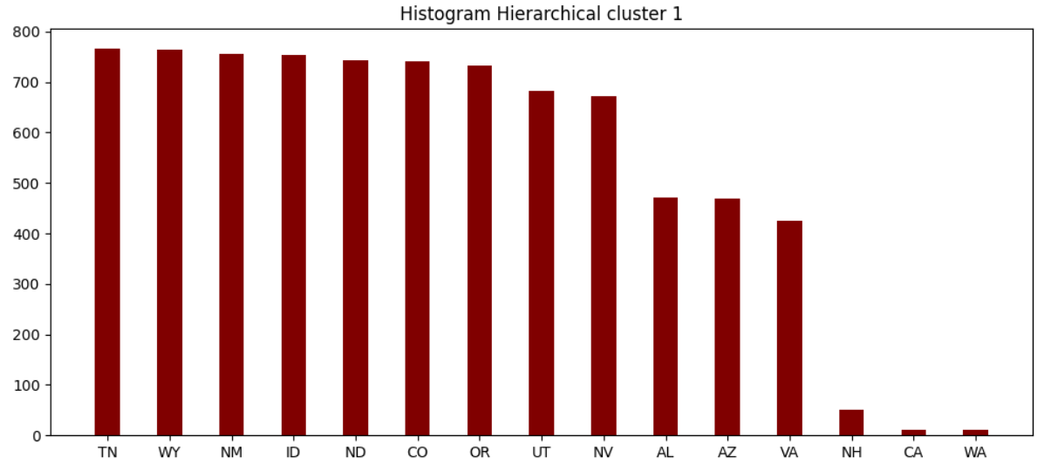

**Fig 60 – Histogram for Hierarchical cluster 1 for unbalanced dataset – 1**

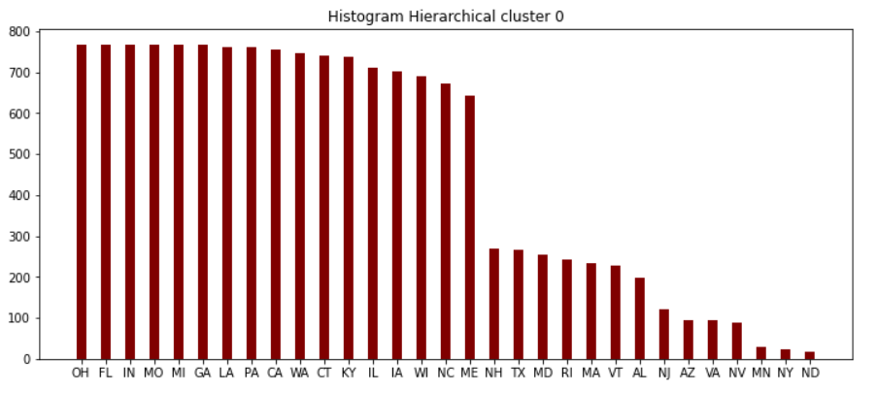

**Fig 61 – Histogram for Hierarchical cluster 0 for balanced dataset – 1**

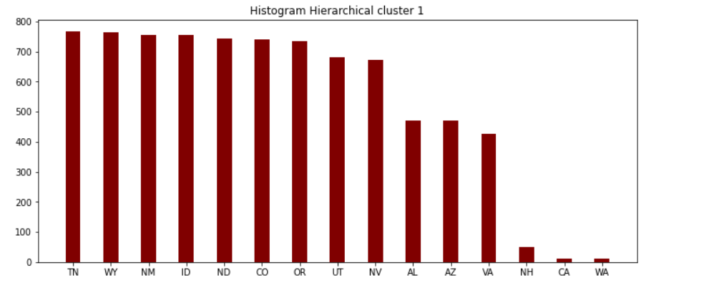

**Fig 62 – Histogram for Hierarchical cluster 1 for balanced dataset – 1**

**From the visuals above, we can conclude that clusters of a particular model is same before and after SMOTE.**

**K Means:** (state codes)

* Cluster 0: TN, WY, NV, ND, NM, ID, CO, OR, UT, VA, AZ, AL, CA, NH, WA, OH, PA
* Cluster 1: MO, FL, IN, MI, GA, LA, PA, OH, CT, KY, WA, IL, IA, WI, NC, ME, CA, TX, MD, RI, MA, VT, AL, NH, NJ, AZ, MN, NY, VA, NV

**Hierarchical:** (state codes)

* Cluster 0: OH, FL, IN, MO, MI, GA, LA, PA, CA, WA, CT, KY, IL, IA, WI, NC, ME, NH, TX, MD ,RI, MA, VT, AL, NJ, AZ, VA, NV, MN NY, ND
* Cluster 1: TN, WY, NM, ID, ND, CO, OR, UT, NV, AL, AZ, VA, NH, CA, WA

**MODEL BUILDING DATASET 2**

**ARIMA - Autoregressive Integrated Moving Average**

It is a type of statistical analysis that uses time series data to understand the data set or foresee new trends. Autoregressive statistical models forecast future values based on previous values. We used time series forecasting using ARIMA for the dependent variable "Often not enough to eat" as well as the independent variable "New Covid Cases" because clustering cannot be performed with the available data.

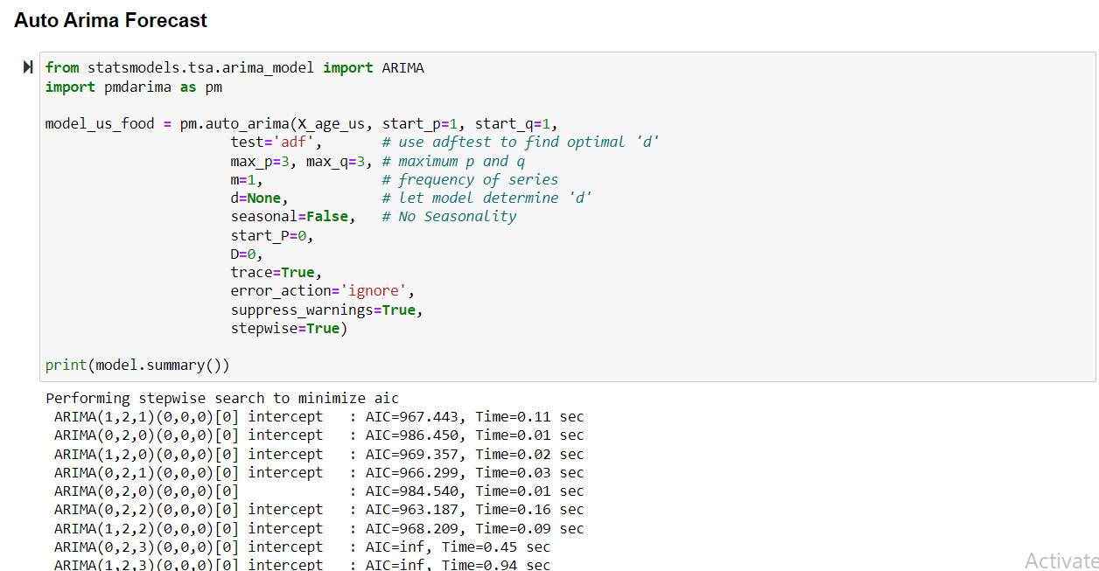

**Fig 63 - Forecasting the Often not enough to eat for the USA for people whose age between '55-64'-64'**

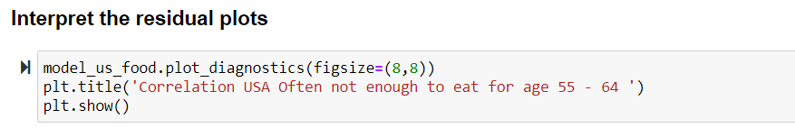

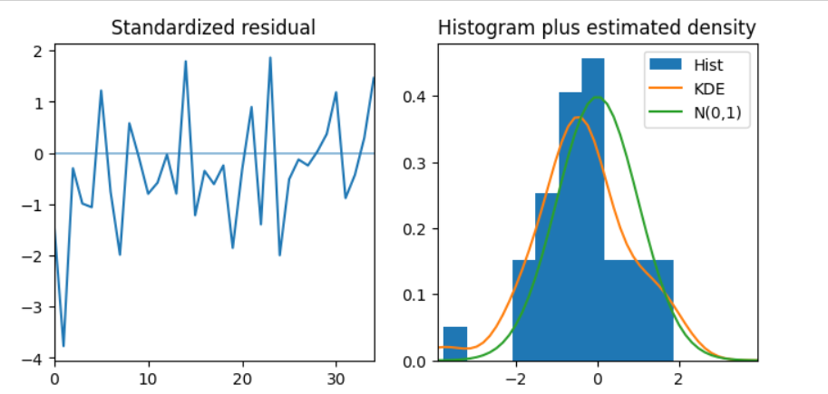

**Fig 64 - Interpreting residual plots**

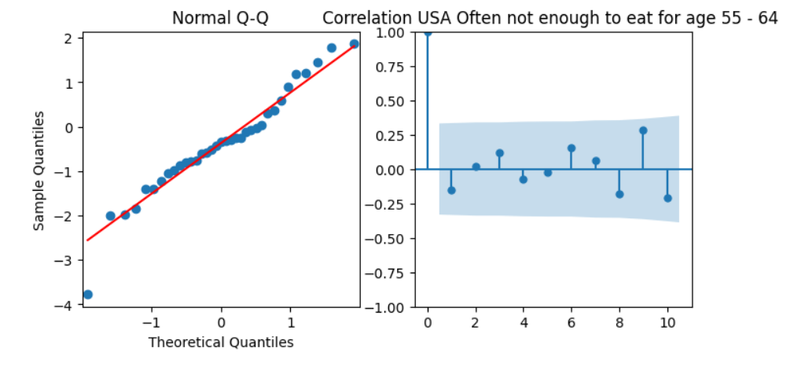

**Fig 65 - Normal Q-Q plot**

**Fig 66 - Correlation USA Often not enough to eat for age 55-64**

In the normal Q-Q plot, All the dots should fall perfectly in line with the red line. Any significant deviations would imply the distribution is skewed. Overall, it seems to be a good fit.

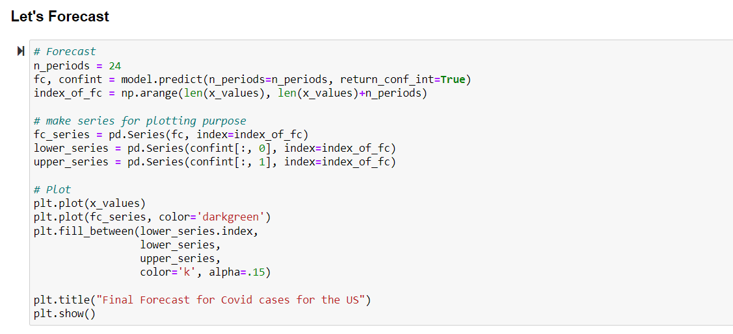

**Fig 67 - Forecast for COVID cases for the US**

**6** **Summary**

This study examined the impact of Covid-19 on air pollution and food insecurity in the United States. Two hypotheses were raised, and the findings are summarized as follows:

**Findings of Hypothesis One (Air pollution)**

The null hypothesis was to examine whether an uptick in COVID-19 cases has no discernible impact on a reduction in polluted air in the USA and cannot predict the Air Quality Index (AQI).  For the alternative hypothesis, an uptick in COVID-19 cases has a discernible impact on a reduction in polluted air in the USA and can predict the Air Quality Index (AQI). Below are the findings of this hypothesis:

1. Null hypothesis is rejected. There is a significant impact of uptick in covid-19 cases on reduction in air pollution and an uptick in covid-19 cases predicts air quality index (p=0.0088).
2. When the population does not stay at home, it impacts Air pollution (p=0.00369).

**Findings of Hypothesis Two (Food Insecurities)**

Null hypothesis: The variables we looked at from the "Covid-19 Food Insecurity" dataset demonstrate that Covid-19 had no effect on the food shortages in the US for various demographic groups in the USA.

Alternative hypothesis: The variables we looked at from the "Covid-19 Food Insecurity" dataset demonstrate that Covid-19 had significant effect on the food shortages in the US for various demographic groups in the USA. The result of this analysis found that:

1. The null hypothesis was rejected (p=0.00009755), thus Covid-19 has a significant impact on the USA food insecurities

**7** **Limitations**

Although we made a concerted effort to address and monitor them, our research had a few limitations.

* The number of null values and incompleteness are highest in the data collection for food insecurity.
* With the information at hand, clustering is not viable for states since the data set on food insecurity consists of time series. So, we made advantage of ARIMA.
* AQI values are categorized into 6 types, but after merging AQI dataset with other pollutants, covid datasets, trips by distance dataset, the final dataset contains only 2 categories (Good, Moderate).
* The overall AQI value is determined by the specific pollutant, but here it is assumed to be determined by all other pollutants and meteorological etc.

**8** **Challenges**

During the proposal stage of this project, we proposed clustering for food insecurity dataset instead we performed ARIMA since it contains time series data where the data related to the survey on weekly basis is given. Using ARIMA we have forecasted what will the future scenario be with the existing data. In our air pollution data set we do not have complete information of variables that impact air quality, so we have collected data of meteorological features such as pressure, wind, humidity etc and air pollutants such as ozone, CO, NO2, etc from United States Environmental Protection Agency. We have then later merged all these datasets into a single dataset by concatenating them year wise then later merged all these datasets into a single dataset on common columns by inner join on county basis, but end up with very less instances around 356, later merged on basis of states, got better number of instances around 27000.

**REFERENCES:**

1) Covid-19 Food Insecurity Data:

Collection of survey data showing the effects of covid-19 on food insecurity

"  <https://www.kaggle.com/datasets/jackogozaly/pulse-survey-food-insecurity-data?resource=download> "

2) US counties COVID-19 dataset:   
“(<https://www.kaggle.com/datasets/fireballbyedimyrnmom/us-counties-covid-19-dataset>) “

3)  US-Environment air pollution": <https://www.kaggle.com/datasets/mayukh18/deap-deciphering-environmental-air-pollution?select=pollution_data.csv> "

"[https://www.kaggle.com/datasets/calebreigada/us-air-quality-1980present](http:// https:/www.kaggle.com/datasets/calebreigada/us-air-quality-1980present) "

4) Wyatt, K. D., Finley, A., Uribe, R., Pallagi, P., Willaert, B., Ommen, S., Yiannias, J., &   
Hellmich, T. (2020). Patients' experiences and attitudes of using a secure mobile phone app   
for Medical Photography: Qualitative Survey Study. Journal of Medical Internet   
Research, 22(5).  " <https://doi.org/10.2196/14412> "

5) Bhattacharyya, M. (2022, September 10). DEAP: Deciphering environmental air pollution.   
Kaggle. Retrieved October 3, 2022, from   
" <https://www.kaggle.com/datasets/mayukh18/deap-deciphering-environmental-air-pollution> "

6) Csafrit. (2022, September 4). US Food Access Data 2019. Kaggle. Retrieved October 3, 2022,   
from   "<https://www.kaggle.com/datasets/csafrit2/us-food-access-data-2019> "

7) Albayati, N., Waisi, B., Al-Furaiji, M., Kadhom, M., & Alalwan, H. (2021). Effect of COVID-19 on air quality and   
pollution in different countries. J Transp Health, 21, 101061.

" <https://doi.org/10.1016/j.jth.2021.101061> "

8) Daniel Teshome Gebeyehu, Conceptualization, Formal analysis, Investigation, Methodology, Resources,   
Software, Writing- Original draft, Writing-review & editing, Leah East, Supervision, Validation.   
    " <https://www.ncbi.nlm.nih.gov/pmc/articles/PMC9362949/> "